E-COMMERCE FOR (Q CAMERA)

Le Quang Tung

ID: GCD17080

Supervisor: Tran Trong Minh

FINAL YEAR REPORT

COM1680 FINAL YEAR PROJECT

Word count:

Contents

ABSTRACT 3

INTRODUCTION 4

General information 5

**Purpose:** 6

**Target:** 6

**Project management approach:** 7

**Content of each chapter:** 7

**1.** **Literary magazine** 7

**2. Legal, social, ethical and professional issues and considerations** 7

**3. Product reviews** 8

**4. Analyze the requirements** 8

**5. Product layout and design** 8

**6. Product research and development** 8

**7. Evaluation** 8

**8. Conclusion** 8

1. LITTERATURE REVIEW 8

1.1 Methodology for conducting a literature search 8

**1.2 Browser applications** 9

**1.3 Programming Languages** 9

**1.4 Frameworks** 10

**1.5 Types of databases** 10

**1.6 Types of Protocols** 11

2. PROFESSIONAL, LEGAL, SOCIAL, ETHICAL AND LEGAL CONSIDERATIONS 12

3. OTHER PRODUCT REVIEW 13

**3.1. brand products 1:** 13

**3.2. brand products 2:** 14

**3.3. brand products 3:** 15

4. ANALYZE THE REQUIREMENTS 16

**4.1 Requirements analysis** 16

**4.2 System comparisons** 17

**4.3 Functional and non-functional needs are discussed in Chapter.** 18

**4.4 Requirements justification** 19

**4.5 MoSCoW prioritization of functional requirements** 21

**4.6 The overall picture of business requirements** 24

5. THE PRODUCT'S DESIGN 25

**5.1. Architecture industry** 25

**5.2. Design at a high level** 25

**5.3. Technology options** 26

**5.3.2 Back end of the system** 28

**5.3.3 Database** 30

**5.4. Diagram of use case** 32

5.5 Diagram Of Entity Relationship 33

**5.6 Wireframe** 34

**5.8** **Activity diagram of the system** 48

6 . THE PRODUCT'S DEVELOPMENT 50

**6.1 System database** 50

**6.2 System front end** 53

**6.3.**Back end of the system 61

6.5 Screenshot of the system 66

6.6 System testing 71

7. CONCLUSION 77

Figure 1: Nikon system 14

Figure 2: Website sony system 15

Figure 3: Website same sum system 16

Figure 4: Picture of business requirements 24

Figure 5: Architecture of the system 25

Figure 6: Diagram of the use case of the system Q camera 33

Figure 7: Diagram Of Entity Relationship of the system Q carera 34

Figure 8: Home page 35

Figure 9: User home page of the system 36

Figure 10: Login page 37

Figure 11: Register of 38

Figure 12: Shop page 39

Figure 13: Admin page manager 40

Figure 14: Manager product (admin) 41

Figure 15: Shop page user 42

Figure 16: Category page 42

Figure 17: Product detail page 43

Figure 18: Manager order detail 44

Figure 19: Payment pay 45

Figure 20: Otp pay 46

Figure 21: Processing product 47

Figure 22: Class diagram of the system 48

Figure 23: User activity diagram 49

Figure 24: Admin activity diagram 50

Figure 25: Database of product 51

Figure 26: Table category database 51

Figure 27: User table database 52

Figure 28: Table order database 53

Figure 29: Mood board color 55

Figure 30: Code index 56

Figure 31: Actual home page 56

Figure 32: Actual shop page 57

Figure 33: Code dashboard 58

Figure 34: Actual manager product 59

Figure 35: Code login.blade 60

Figure 36: Actual login page 61

Figure 37: Provider forder 62

Figure 38: Mvc model 63

Figure 39: Code controler 64

Figure 40: Code router 65

## ABSTRACT

In the sales system in general, and the technology sales system in particular, the field of e-commerce has shown to be a highly effective tool and a step ahead, in addition to the manual approach used in the past. Connecting businesses and customers has proven to be quite beneficial. The main objective of this study is to determine the current status of e-commerce in the system of buying and selling technological products as well as its potential influence. The study looks at things like corporate acceptance, use of computers, as well as the Internet, like the financial of e-commerce impact on these businesses. A study looking at the relevance of buying food online, factors influencing the use of e-commerce, and some recent e-commerce advances. Use media and mobile access to promote e-commerce digital goods. Especially before the impact of the COVID-19 epidemic on the field of e-commerce business.

**PREFACES**

In simpler terms, e-commerce refers to the buying and selling of goods and services over the Internet and other electronic channels. All activities, including transactions, purchases, payments, ordering, advertising, and shipping are included in these transactions. In the current situation of covid 19 epidemic with many complicated variables, instead of buying and selling directly in the traditional way, I want to update and change my business model. I want to use my existing skills and expertise along with my research, I want to build a website for my business. Through those experiences, I also want to challenge myself and apply the knowledge that I have learned before to apply for this project.

**GENERAL VISION**

The deepest words from my heart that I would like to sincerely thank for the care and enthusiasm of teacher Tran Trong Minh, who has guided me for a long time. During each lesson, teachers support and guide in detail with solutions and directions and also provide direct feedback to quickly solve students' questions. Along with the mistakes in the learning process, the teacher is still happy to forgive. Thank you very much, along with my friends, who have accompanied me with useful advice during the past time.

And the last word I would like to say is that I am grateful to Greenwich University for organizing this course so that I can attend and meet people in the same major to learn and hone my skills and knowledge information technology industry.

INTRODUCTION

The 4.0 era with a strong boom, in addition to the strong development of technology and the Internet, the modern and progressive level of E-commerce is increasingly promoted and enhanced, and followed by thousands of dollars. a wide range of services and applications on e-commerce are also opened up very widely. Now, many of the industry leaders in digital technology realize that the strong push in e-commerce will be the explosive growth of this digital platform that will be easier to adopt. The development of logistics services at home or anywhere where there is an internet connection to communicate with clients makes this business platform also attractive to digital businesses. Buyers, especially those interested in technology, are increasingly using online services as their disposable income increases, electronic payments become more reliable and convenient, and the scope of retailers’ Supply and delivery scale is getting stronger and stronger. The system will provide consumers with a website that has all the details on every digital product sold and can order and pay with ease.

## General information

Many businesses have been forced to close due to the outbreak of covid-19, with the digital business sector bearing the brunt of the damage. This traditional electronics industry faces numerous long-term challenges. The market economy, supply chain, cash flow, and sales are a few examples. Some e-commerce companies, on the other hand, have a different image; they do business quickly during the pandemic when tourism and hotels are completely disrupted.

The electronics industry is one of the most developed in many countries; this industry provides a large number of jobs in the economy, and thus it makes a specific contribution to people's socioeconomic growth. Many business chains are experiencing difficulties as a result of the new covid-19, and many electronics stores have been forced to close. The important thing now is to revive this industry because so many people depend on it; on the other hand, the state supports all organizations, including electronics companies. We know that no industry can survive on its own without government support. As a result, large companies dealing in electronic technology must develop their strategic plan to increase sales. The adaption of e-commerce can keep this enormous industry out of the epidemic with concentrated efforts. One of the major objectives in the current situation is to keep the economy afloat. As a result, the contributions to present economic growth, particularly in the technology industry, will be discussed in this article.

### **Purpose:**

The objective of the study was to examine the multiple aspects of using e-commerce platforms to combat the current and possible future covid-19 pandemic in terms of technology devices business.

### **Target:**

- Create and build a website that is organically popular to reach large clients and different customer groups:

• Well-organized content and design.

• User personalization and optimization.

• Users register and log in to the website.

• Users can find things to buy.

• Users can monitor their orders.

- Convenient payment:

• Very easy wallet payment for customers.

- Admins can manage and customize their accounts:

• Manage bespoke business product data .

• Keep track of and manage the status of your orders.

### **Project management approach:**

Scrum is an agile way of development that emphasizes iterative and incremental methods for creating project functionalities. The fundamental goal of Scrum is to address customer needs by creating a community that values ​​open communication and accountability. The development process begins with a general understanding of what to build, then a prioritized list of project features is developed.

**Explain why a particular method or model should be used**

Scrum is a software development methodology based on Agile concepts. Scrum assigns three roles to the software development team, each with its own set of responsibilities. Four major occurrences are covered under the Scrum Rules (Creat Sprint Plan, Daily Scrum, Sprint Feedback, and Sprint Improvement). And when I check the importance of the needs, I plan each Sprint, the length of which is determined by the relevance of the criteria. In each sprint, I begin by deploying, testing, and evaluating the quality against the established requirements; any problems are resolved in the next sprint.

We see that, when using the "better first" technique, the elements that bring the most value to the project are always completed first. As a result, it is therefore the most valuable component of the sample, and the method is constantly being improved.

### **Content of each chapter:**

### **Literary magazine**

Mobile Apps, Databases, Programming Languages, Browsers, Frameworks, Protocols, and APIs are among the topics and areas covered in this section.

### **2. Legal, social, ethical and professional issues and considerations**

Help deal with legal issues that may arise in the process of improving and implementing the system.

### **3. Product reviews**

Evaluate the project's system to compare web-based systems.

### **4. Analyze the requirements**

This section includes the requirements analysis, which entails identifying and detailing the proposed solution's expectations and needs, as well as functional specifications and research findings.

### **5. Product layout and design**

In this area, you'll find the design concepts and wireframes for the project's suggested solution.

### **6. Product research and development**

The implementation of the solution and the technological platforms employed in the system development process is discussed in this part.

### **7. Evaluation**

This section covers details on the product as well as the project's plans.

### **8. Conclusion**

The project's conclusion will be stated in this section.

# **1. LITTERATURE REVIEW**

## 1.1 Methodology for conducting a literature search

When doing a document review, try to be as thorough as possible. It's crucial to know where to go for information. Working through the steps will help you locate the ideal database for your study topic.

• Start with research databases;

• Use specialized databases to narrow your search;

• Look for books, theses, and other resources

In this investigation, regular Google search libraries were used to conduct a complete and exhaustive search. The search yielded materials such as conference proceedings, book chapters, and journal articles.

The following is a list of related publications concerning the research topic:

### **1.2 Browser applications**

The Hypertext Transfer Protocol (HTTP) oversees the transmission of text, images, and video across the internet. You can travel anywhere on the internet with a web browser since it collects data from multiple websites and displays it on your computer or mobile device. It is used to transfer data back and forth between devices.

Some widely used browsers:

• Google Chrome - the best browser today.

• Safari - Apple's web browser

• Firefox - The Mozilla Foundation's open-source browser

• Internet Explorer - Microsoft's browser. Cause a lot of controversy among web developers.

### **1.3 Programming Languages**

Programming languages ​​are used by programmers to create scripts, software, and other sets of instructions that can be understood by computers. A compiler is software that converts source code into machine language that a computer can understand interpreter to run scripts and programs written by programmers without requiring the use of a compiler.

The most popular languages ​​today:

• Javascript is a popular programming language for creating interactive web pages, used in Meteor and several other frameworks.

• Python - using Django framework and in a web application, software development, data science.

• PHP - PHP(PHP: Hypertext Preprocessor). The term refers to a variety of scripting or scripting languages, suitable for developing server-based applications.

### **1.4 Frameworks**

A framework is a pre-written code that configures a set of frameworks and packaged programming libraries. We provide built-in features such as models, APIs, and other elements to simplify the development of rich, dynamic web applications. Frames like ours have prefabricated basic foundations, you just build and furnish as you like.

• Ruby on Rails is a full-stack framework based on Ruby.

• NodeJS is an open-source and cross-platform JavaScript runtime environment used to run web applications outside of client browsers.

• Django is an open-source, high-level web programming framework written in the Python programming language

• Phonegap/Cordova - mobile framework containing iOS and Android native APIs for use by programmers while developing mobile apps.

• Foundation - user interface framework for developers to develop HTML/CSS/Javascript.

• WordPress - Drupal is an open-source PHP language that currently runs about 25% of all websites.

• Microsoft's full-stack framework, the.NET Framework

• Ember.js is an open-source client-side JavaScript framework, while Angular.js is a JavaScript framework for writing web interfaces.

• Laravel is a free, open-source PHP framework for software and application development, following the MVC model.

### **1.5 Types of databases**

SQL and NoSQL are the two most common database types. NoSQL gives you a lot of alternatives when it comes to creating and sustaining projects. NoSQL databases make it easier to legally, correctly, and securely secure data than traditional databases.

• MongoDB is the only free and open-source NoSQL database powered by Meteor.

• Redis is a widely used and feature-rich key-value storage system. When it comes to data access, it's lightning fast, but its data storage capacity is limited.

• PostgreSQL is an object-relational database management system.

• MySQL is a famous open-source database management system that operates under the client-server model.

• Oracle is a business-oriented SQL database.

• SQL Server - storage for data based on the RDBMS standard.

### **1.6 Types of Protocols**

Protocols are established instructions that define how to format, transmit, and receive data to computer network devices

• HTTP is one of the basic hypertext transfer protocols on the Internet, between the user's computer and the server's server.

When you type

Which begins with <http://www.google.com,> which requests a web page from a Google server and then gets a response using the site's HTML, CSS, and javascript.

•DDP is a protocol that is vastly used in a Meteor (Data Distribution Protocol). Websockets are used by DDP to keep clients and servers open. Because of this constant connection, websites and data can be updated from time to time without reloading the browser.

• REST is used for application programming interfaces (APIs). It supports standard data transfer techniques such as GET, POST, and PUT, as well as custom methods.

# **2. PROFESSIONAL, LEGAL, SOCIAL, ETHICAL AND LEGAL CONSIDERATIONS**

They do, however, confront several obstacles, including a lack of understanding of fundamental norms and standards as well as financial constraints. In addition, SMEs face staff shortages and difficulties in creating local data centers. In each priority category, public and private priorities must be balanced:

• Regulation of electronic transactions: E-commerce, like traditional commerce, is made up of transactions and agreements between parties in the supply chain. Validating an agreement, agreeing to pay, and resolving disagreements are among the challenges faced.

• E-Payment: E-commerces service providers want to know that their payments will be completed as soon as possible. As a result, e-payments are routinely monitored globally. Both the public and private sectors place a high priority on preventing fraud and adhering to banking standards, such as providing answers to security problems at the transaction level.

• E-Signatures: Electronic signatures, which mark the completion of a contract, need to be clearly defined. Checking signatures and handwritten signatures are the same or basic authentication process validation are two regulatory approaches that can be applied.

• Data Security: E-commerce has grown and navigated the unknown volume of data around the world. Some states regulate information globally (often through master guidance), while others regulate data by industry. Companies are now attempting to build new products and services by utilizing the massive amounts of data available.

• Cybersecurity is becoming a global challenge, much like data protection. Attacks on computers and cyberspace are increasing and increasing in intensity, posing many risks to the community. National cybercrime laws, industry-led standards and recommendations, and most recently, comprehensive cybersecurity law have all contributed to the regulatory environment.

• Consumer Protection: Traditional consumer protection measures, according to the report, are not enough to combat specific e-commerce practices. Many governments are confused as to how to regulate this protection.

# **3. OTHER PRODUCT REVIEW**

### **3.1. brand products 1:**

Nikon Corporation, also known as Nikon, is a large and developed corporation, that has many branches in many countries and is headquartered in Tokyo, Japan that manufactures cameras, and optical equipment. Nikon is a famous Japanese camera manufacturer, if you buy the Nikon line, it helps you reshape the way you take photos and share with others. Nikon introduces the SRL line of digital cameras that have revolutionized the company's technology with the high-quality durability and speed of digital cameras that make them irresistible for those Who are passionate about taking snapshots.



Figure 1: nikon system

Nikon is a brand that is constantly improving the photography, imaging and optical industries. That's why Nikon has a quality camera that is reliable and trusted by many. Nikon offers you both basic and advanced photography techniques to help you develop your photography skills.

A high-tech camera that will tackle all the basics of creating images and using depth, as well as advanced techniques like avoiding light, and making creative use of white balance and color settings. Nikon gives you cutting-edge imaging techniques that give you a lot more freedom to work with your artistic inspiration. The typical product of Nikon today is the camera.

For customers, the website has a nice design with typical Nikon color tones, they already know about Nikon and use the website to order, and the products displayed on the website are difficult to buy. The payment services are not modern and convenient, the website is too simple.

### **3.2. brand products 2:**

Compare Seconds is a Japanese multinational corporation, headquartered in Tokyo, one of the world's electronics corporations. As one of the leading companies in the field of electronics, Sony is very successful in the production of televisions, cameras, laptops and other consumer goods.

Sony cameras have one of the best DSLR lenses on the market today. The most special lens is the G series lens, capable of sharp acquisition in the areas you need to focus on and blurring the background, which is very suitable for novice photographers who can adjust themselves at any angle to The photo is the best.



Figure 2: website sony system

According to the store's theme, this website is developed in an American manner. Because the quality of the products sold has been proven, the website focuses on the company's franchising system and policies rather than the products themselves. One disadvantage is that this site offers a wide range of services, but selecting products is too time consuming.

### **3.3. brand products 3:**

The third choice is Samsung Corporation, is a large corporation of Korea with many branches around the world and the head office is located in Samsung Town, Seoul. Most of its subsidiaries operate under the Samsung brand, and is the largest commercial group in Korea. Although it has just entered the camera market, Samsung has still won a lot of attention from the photography world thanks to its low-cost, high-quality camera.

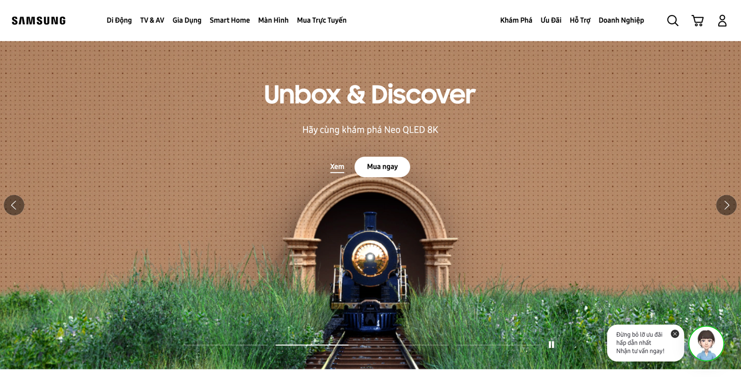

Figure 3: website samsum system

And a special feature of Samsung cameras is the Smart Camera app installed on Android or iOS (smartphone / tablet) that will help users easily transfer photos from the camera to mobile devices, and at the same time can use it directly. The phone as a remote photography support device is very convenient to take pictures of all different shapes and styles when you travel without a photographer.

Regarding samsum's website, customers can easily shop with many support services, but accordingly, this website is difficult to make payment for new customers.

# **4. ANALYZE THE REQUIREMENTS**

### **4.1 Requirements analysis**

It's the process of determining what a new or upgraded product's users want. These criteria, or features, must be quantifiable, meaningful, and particular. It's necessary to conduct a requirements analysis before moving on to the system design and implementation phase.

In the Scrum technique, requirements analysis entails ongoing interaction with the user to accurately determine the expected performance. Instead of trying to meet user expectations with requirements, focus your efforts on making sure that the final system or product meets the customer's requirements. To avoid feature errors and save the project build end to end.

### **4.2 System comparisons**

The following table compares the product's developed features to those already on the market:

|  |  |  |  |  |
| --- | --- | --- | --- | --- |
| Originality | Q camera | Nikon | Sony | Samsum |
| Capabilities for handling content | Ok | Ok | Ok | Ok |
| Payment is simple to use. | Ok | No | No | No |
| Search engine friendly code and design | Ok | Ok | No | No |
| Article in the blog section or a general article | No | Ok | Ok | No |
| Multiple payment methods (Credit Card, PayPal, PO, Terms, and so on) are available. | Ok | No | No | Ok |

Sumary:

The elements compared in the table above are the essential parts required for an e-commerce system, and a useful website requires additional criteria. For the system to be utilized by a large number of people, it must be based on several elements, including features, interface, and suitability to the needs of different living situations. The characteristics of the websites compared above will not satisfy the needs of users as well as they did during the Covid-19 outbreak. As a result, the system I'm creating will be focused on the demands of users during epidemic seasons, as well as tips for living safely with the epidemic.

### **4.3 Functional and non-functional needs are discussed in Chapter.**

|  |  |  |
| --- | --- | --- |
|  | Types of requirements | User story (requiment) |
| 1 | F | Register and login as a customer to use all the functions of the website. |
| 2 | F | Product details can be searched and accessed as a user (Customer or Registered User). |
| 3 | F | You can add things you want to buy to your cart as a Registered User. |
| 4 | F | I can update the order in my cart because i am a registered user. |
| 5 | F | As a registered user, I have access to a variety of payment options for cart orders. |
| 6 | F | As a registered user, I can track the status of my order's shipment. |
| 7 | F | As an administrator, I can keep track of how many orders have been placed and how much money has been exchanged. |
| 8 | F | I can add, update and delete products when I am the admin. |
| 9 | F | I can edit the user's placed order status as an admin. |
| 11 | N-F | The website should be simple to navigate and use. |
| 12 | N-F | Administrative functionality should be considered for different sites so that you can edit who can create, view, copy, change or delete data. |
| 13 | N-F | Regardless of the number of users or website traffic, performance should be as fast and efficient as possible. |
| 14 | N-F | Maintenance costs are factored into corporate budgeting. |
| 15 | N-F | In terms of website scalability, you should search for a solution that is future-proof so that the website may expand and include new features and services without compromising its performance. |

### **4.4 Requirements justification**

Requirement 1: To utilize the website's primary features, you must create an account. This requirement is intended to protect and help regulate users' access and use of information on the website.

Requirement 2: Visitors or registered users can easily access the products on the website; They can view full product information before placing an order.

Requirement 3: Registered customers use the add to cart option to place an order after locating the product they want.

Requirement 4: Registered users can adjust quantity or delete products in their cart from the cart page.

Requirement 5: After reviewing the items in the cart, users can pay using a variety of methods, including credit cards, vnpay, and others.

Requirement 6: After successfully logging in and placing an order, the user can track the delivery progress through the account page, which includes the user's profile and purchase history.

Requirement 7: You will be redirected to the dashboard, which provides full level of information when you are logged in as an administrator.

Requirement 8: You need to log in with an admin account to use the functions of adding, editing and deleting products.Then choose the product management section to go to a page that lists all of the products that can be used to perform the desired feature.

Requirement 5: After reviewing the items in the cart, users can pay using a variety of methods, including credit cards, vnpay, and others.

Requirement 6: After logging into the website and placing an order, the user may track the order's shipment progress via the account page, which also includes the user's profile and purchase history.

Requirement 7: As an administrator, you will be sent to a dashboard that gives detailed information about the website when you log in.

Requirement 8: You must log in with an administrator account to conduct the functions of adding, editing, and deleting products. Then select the product management section to display all the products and implement the desired feature.

Requirement 9: When a user successfully places an order on the website, the administrator will be able to access information and update the shipping status for the order through the order management page.

Requirement 10: The admin dashboard contains data about orders and revenue generated for all transactions made by all users on the site.

Requirement 11: Users should be able to complete their tasks in a single page visit. This will improve the website's worth as well as the user experience.

Requirement 12: Only the system data administrator can give roles and adjust access rights to the system. Websites that handle transactions involving currency, financial data, or sensitive user data must prioritize security. This will increase customers' trust in the website and make them brand evangelists.

Requirement 13: Performance requirements are an important part of the system as it has to handle a large amount of user traffic at the same time to avoid mistakes when using it.

Requirement 14:Increased website maintenance from the start means less time and money spent identifying and resolving potential system faults.

Requirement 15: In the future, the site needs more memory to handle more transactions and can add localization tools as it wants to grow in other markets.

### **4.5 MoSCoW prioritization of functional requirements**

|  |  |  |
| --- | --- | --- |
|  | **Right of Priority** | **Prioritization justification** |
| **1** | **Necessary** | Customers must register for an account to utilize all of the website's functions, which is also a vital step in protecting user information and assisting administrators with order management. |
| **2** | **Necessary** | Them can find the goods they desire before deciding to order, which would improve usability, because forcing customers to register to see the product can cause problems for the most discerning customers. |
| **3** | **Necessary** | Since the add products to cart function is the primary function for order processing, all ancillary services would not be available without this function. |
| **4** | **Necessary** | When a consumer wishes to place an order, they must double-check the amount of things in their cart and can add or delete items before proceeding to checkout. Users can manage their orders using this feature. |
| **5** | **Necessary** | The multi-option payment mechanism on a commercial website is critical because, in the event of an epidemic, this function helps to keep a distance and avoid close contact, ensuring the safety of a large number of shippers. |
| **6** | **Necessary** | When users place an order successfully, they are most interested in whether the order has reached the carrier or not, has been shipped or not, so this function will help users track the progress of their order. |
| **7** | **Necessary** | When there are any changes to the website, the admin can preview the website after the change is made. With this function, the administrator can use his account as a regular registered customer. |
| **8** | **Necessary** | The administrator can utilize the data editing options directly on the website to make it easier to control the information presented on the website. This will make it easier and faster to manage the supported data. |
| **9** | Necessary | This function will efficiently assist the administrator in managing the products sold on the website by allowing them to add, update, and delete products. |
| **10** | Necessary | With the requirement to track user orders, this function requires administrator assistance. Once the order has been received and processed, the administrator will update the order status immediately on the administration page. This will make controlling order status and tracking users' orders much easier. |
| **11** | **may be necessary** | Completed orders will be counted by amount on the admin dashboard after every user activity on the site. This function has no bearing on the website's other functions; it simply allows the administrator to learn more about the revenue generated on the site. |
| **12** | Necessary | For a commercial website that holds a lot of valuable information on people visiting the store, security is critical. If a website is not highly secure, sensitive information can be taken, lowering the user's faith in the site. |
| **13** | Necessary | Performance is an equally significant aspect of a web; this is the factor that affects the quality of the website. Websites possessing fast processing speed will improve the quality of service usage of users while also ensuring that the website does not have odd issues when a large number of visitors use the service at the same time. |
| **14** | **may be necessary** | Performance is an equally significant aspect of a site this is the factor that affects the quality of the website. Websites possessing fast processing speed will improve the quality of service usage of users while also ensuring that the website does not have odd issues when a large number of visitors use the service at the same time. |
| **15** | **needed later** | The major tasks of a website were identified from the start of the project, with an eye on emerging technologies being implemented to the website meet all user needs. Users' needs will vary in the future, posing the challenge of inventing new services to meet their needs. |

### **4.6 The overall picture of business requirements**

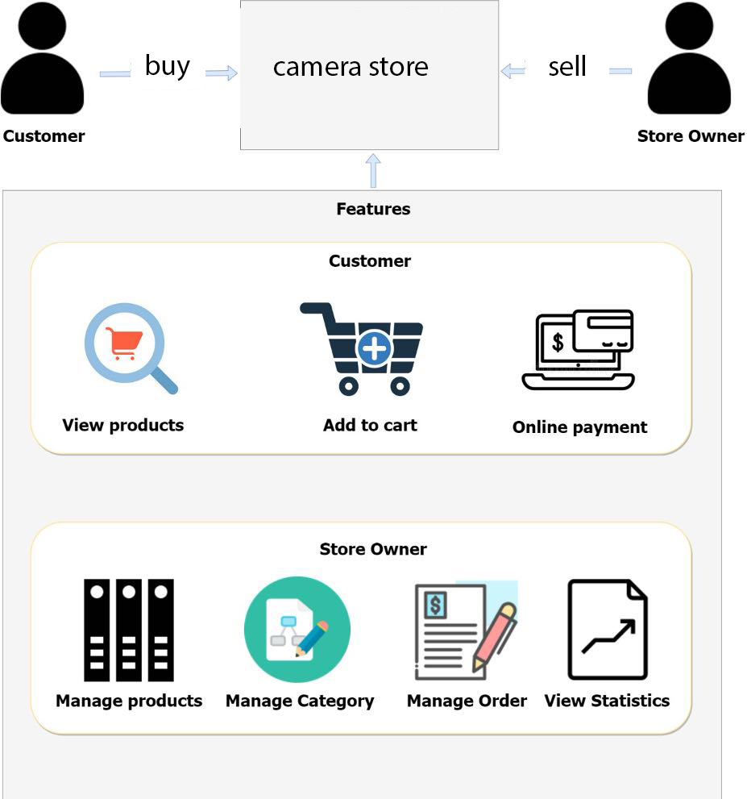

Figure 4:picture of business requirements

## 5. THE PRODUCT'S DESIGN

### **5.1. Architecture industry**

E-commerce system based on website interface. For system development, the client-server architecture is used; with this model, a machine acts separately as client and server. The client sends data to the server that provides the service the client requested via a graphical interface.

The e-commerce system should be able to communicate with and respond to the client's data processing demands continually. The business rules of the performance architecture are applied to both sides, helping all entities work faster and better.

### **5.2. Design at a high level**

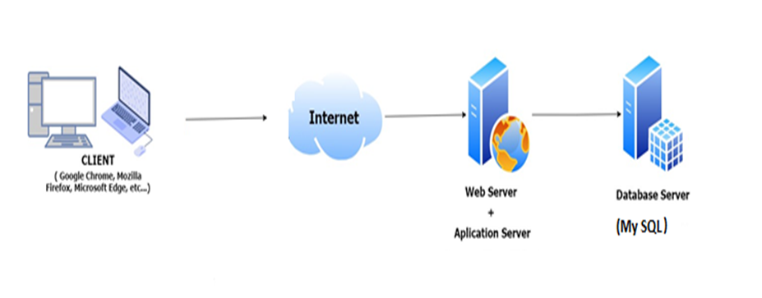

Figure 5: Architecture of the system

The web application's code is divided into two parts: the back end and the front end. The front end is in charge of:

• show the data it receives from the back end in a readable way

• show the interface page that the guest sees in their browser

• add many other functions to increase user interaction

The back end is in charge of:

• Handling User Requests

• process along with the database to get the right data and send it to potential customers

On a more detailed level, the controller is in charge of handling user requests in the web backend, gathering and arranging all the data needed to make the request and then passing that data to the interface to render the web page. The design is described in more detail in the following sections.

### **5.3. Technology options**

**5.3.1. The User Interface**

* **Framework bootstrap:**

This is open-source code built by Mark Otto and Jacob Thornton to make web UI programming faster and easier. Allows using all HTML and CSS-based design templates with different functions and components, for example, navigation, grid system, image carousel, and buttons.

Although Bootstrap saves developers time and effort from having to manage templates, again and again, Its goal is to build responsive websites. Enable your website's user interface to work well on any screen size, on phone or desktop screens.

As a result, developers no longer have to build multiple sites specific to each device and the scope is limited.

The popularity has caused many Bootstrap communities to emerge. It's a great place for developers and designers to gain knowledge and discuss the latest framework patches.

**The core parts of bootstrap make it easy to manage the user interface.**

**-Bootstrap.css**

Bootstrap.css is a CSS framework for creating and managing website layouts. While HTML handles the content and structure, CSS handles the layout of the web page. Therefore, both need to coexist to perform a particular action.

CSS lets you build a consistent look and feel across as many web pages as you like. Now you can say goodbye to manual edits that take you hours to align.

With CSS, all you need to do is link the web pages to the CSS file. Any necessary changes are made in that file.

CSS functions are not limited because they can be used to format other aspects of a web page, such as tables and image layouts.

**- Bootstrap.js**

This file is the main Bootstrap file. Includes multiple JavaScript files to interact with the web page.

To reduce the time when writing JavaScript statements, developers tend to use jQuery. It contains a popular open-source, cross-platform JavaScript library that allows to addition various functionalities to a web page.

**Here are some examples of what jQuery does:**

+ Can get data from another location flexibly

+Create widgets with a collection of JavaScript plugins

+ Create customizable animations using the CSS property

+ Add animation to the website

**-Glyphicons**

Icons are an important part of the website interface to help increase the aesthetics of the web. They are associated with some important actions and information in the user interface. Bootstrap uses Glyphicons to help optimize that need.

Bootstrap contains an unlocked set of Halflings Glyphicons for free use. Although it is a free version, the interface is standard but full of necessary functions.

Of course, Bootstrap has undeniable advantages. If you need a mobile-first website that is clean and not too fussy about layout, Bootstrap can save you a lot of dev time.

However, to be able to master Bootstrap, the time it takes to master it is not overnight. There is so much to remember, you will often go back and forth in the document to check how you intend to do it the Bootstrap way.

### **5.3.2 Back end of the system**

• Laravel

Laravel is a free and open-source PHP framework, The first version of Laravel was created by Taylor Otwell in June 2011 as an alternative to Codelgniter. Laravel was born to support the development of model-driven web applications MVC

Laravel is developed under the MIT license, with the source code hosted on git

Born not early compared to many other frameworks, Laravel has quickly created great power, was evaluated for quality, and trusted by many people.

Laravel exists a lot of interesting points that programmers cannot ignore such as:

- Use the latest PHP features: With Laravel version 5, developers can access the new features PHP has to offer.

The resources available are plentiful with a wide variety of materials that are great for programmers.

- Fast speed: Laravel provides maximum support for building websites or large projects in a short time.

- Ease of use: when your PHP knowledge is not solid, you can still build a great website on your own.

Easy Database Migration: Laravel helps you maintain the database structure without recreating it. It is possible to write PHP code for the control instead of using other types like SQL. Also, you can roll back the most recent changes in the Database.

- Better and Higher Security: Use PDO to prevent SQL attacks and hidden token fields to combat CSRF attacks so users can focus on product development.

Laravel is a free and open-source PHP Framework with clear and coherent syntax. Laravel is developed based on the MVC model. Laravel tries to solve development problems by reducing common tasks used in the majority of web projects.

MVC is a code supplement model with 3 parts. Each component has a separate and independent mission from the other components. Detail:

- Model

This is where the business interacts with the data or the DBMS. The component contains all business logic, processing methods, database access,and data description objects such as Classes, processing functions,etc.

- View

Is where interfaces such as buttons, input frames, menus, images, etc. Responsible for information display, and user interaction, containing all GUI objects like text boxes, Images, etc.

- Remote control

This is where user requests are received. The Controller component will include functional classes that handle much of the business logic. Help get the right data and information and display it to the user through the View class

What are the pros and cons of Laravel?

- Advantages of Laravel

+ Provides the latest PHP features

Developers can access the latest features that PHP has to offer. for Namespaces, Interfaces, Overloads, Anonymous Functions, and Array Syntax will no longer be as long as before

+ Great resource and always available in the library

Laravel contains many resources, developers can find many different types of documents to refer to. Each released version has the appropriate source material for each application

+ Attach Email Task

This is a framework with built-in API on the SwiftMailer library. So the programmer can send mail through local or cloud-based services

+ Faster processing

Laravel helps to optimize the time to create a website or large project. So it is used a lot by technology companies and programmers to build their products

+ Easy to use

It was well-received and widely used. It only takes you a few hours to develop a small project with the most basic knowledge of PHP.

+ High security

Laravel provides many powerful security features that help users focus more on improving their products.

Use PDO to prevent SQL injection attacks

Use Hidden Field Tokens to prevent CSRF. attack

Normally, variables in Laravel Escape will support the Default View. Hence XSS. The attack can be avoided

**5.3.3 Database**

MySQL is a configurable database system (RDBMS) in client-server format. RDBMS stands for Relational Database Management System.MySQL, Apache, and PHP are all interwoven. MySQL uses databases to manage data. Many relational tables can be found in the database. The SQL language has the same access and code as MySQL.

MySQL supports a variety of storage engines, including InnoDB, CSV, and NDB, for storing and retrieving data. MySQL also replicates data and partition tables for improved performance and durability. MySQL users do not need to learn any additional commands to access their data; they can use common SQL commands.

MySQL is written in C and C++ and can run on more than 20 platforms, including Mac, Windows, Linux, and Unix. Many data types are supported by RDBMS, including signed and unsigned integers of length 1, 2, 3, 4, and 8 byte(s), FLOAT; DOUBLE; CHAR; VARCHAR; BINARY; VARBINARY; TEXT; BLOB; DATE; TIME; DATETIME; TIMESTAMP; YEAR; SET; ENUM; and OpenGIS kinds. Strings also have both default and variable lengths.

Use encrypted passwords and an access system with server-based verification for security. The MySQL Client connects to the MySQL Server via multiple protocols, including TCP/IP on any platform. In addition, MySQL includes several client programs and utilities, as well as the command line and administration tools.

The following are the database's strongest features:

Ease of Use: A stable, easy-to-use, high-performance cross-platform database with a large collection of extremely useful utility functions.

High security: MySQL is compatible with applications that require access to databases on the Internet and provides a high level of security.

MySQL provides many SQL functions, both direct and indirect, just like what to expect from a relational database management system.

MySQL is scalable and powerful, with the ability to control large amounts of data and the ability to scale if needed.

Fast: Giving different criteria makes MySQL more efficient and cost-effective, helping to proceed faster.

MySQL is freely available under an open-source license. So you don't have to

Large Database Support: MySQL supports up to 50 million databases or more in one table. The default file size for a table is limited to 4GB, however, if the operating system can support it, the restriction can be expanded. It's possible that the theoretical limit could reach as high as 8 million TB.

MySQL is an extremely powerful program in and of itself. It can perform a wide range of functions often found only in the most powerful and expensive database solutions.

MySQL comes with several high-level security measures. As a result, it's ideal for apps that use the internet to access databases. Multi-features: It provides many useful SQL functions from a relational DBMS both directly and indirectly.

Highly customizable: thanks to the GPL open-source license, programmers can modify the MySQL software to better suit the usage environment.

**5.4. Diagram of use case**

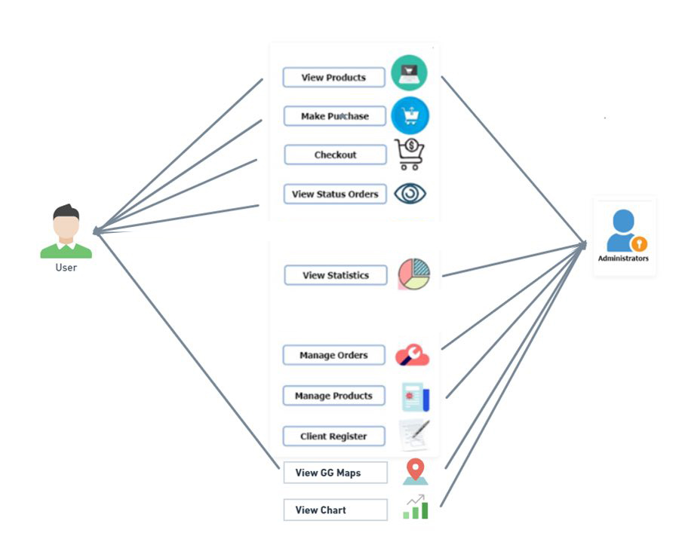

Figure 6:Diagram of the use case of the system Q camera

5.5 Diagram Of Entity Relationship

This is an ERD diagram of an electronic equipment business's E-Commerce database (Camera). ERDs (Entities-Relationship Diagrams) are diagrams that show how entities interact

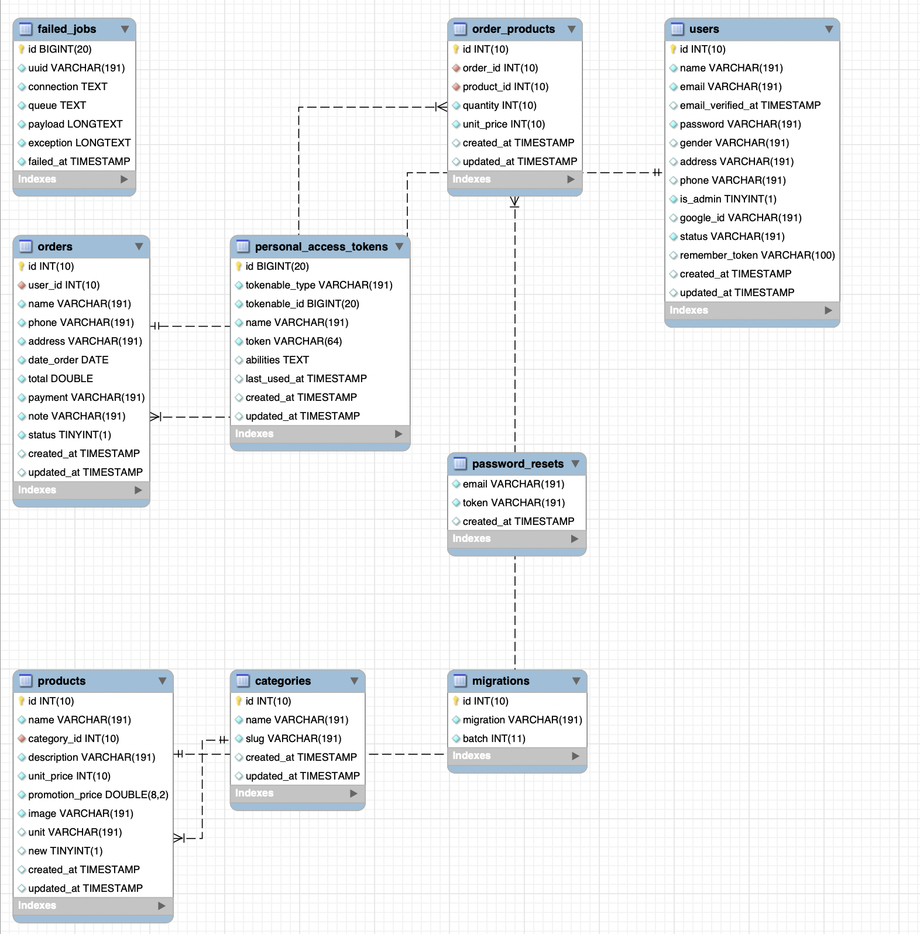

Picture 7:Diagram Of Entity Relationship of the system Q camera

**5.6 Wireframe**

**5.6*.*1. Wireframe for the Web Interface**

* + **User/Guest Interaction**

-website’s most important page

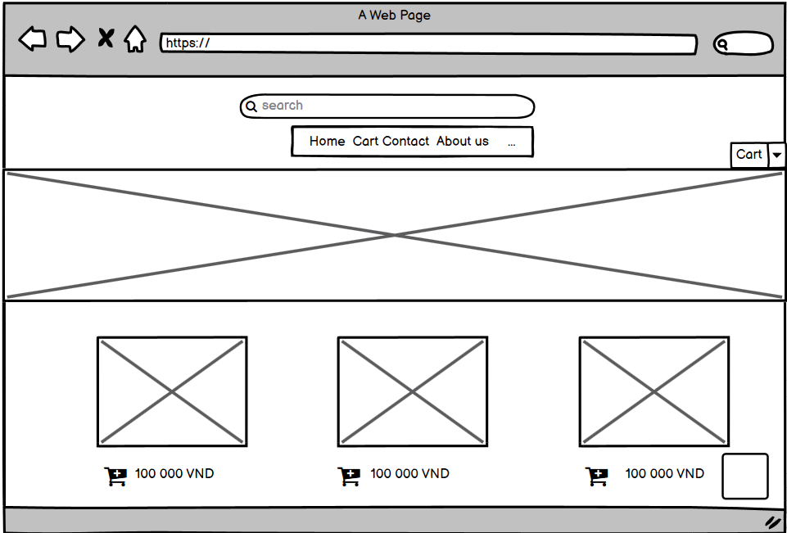

Figure 8: home page

-website shop page of the system Q camera

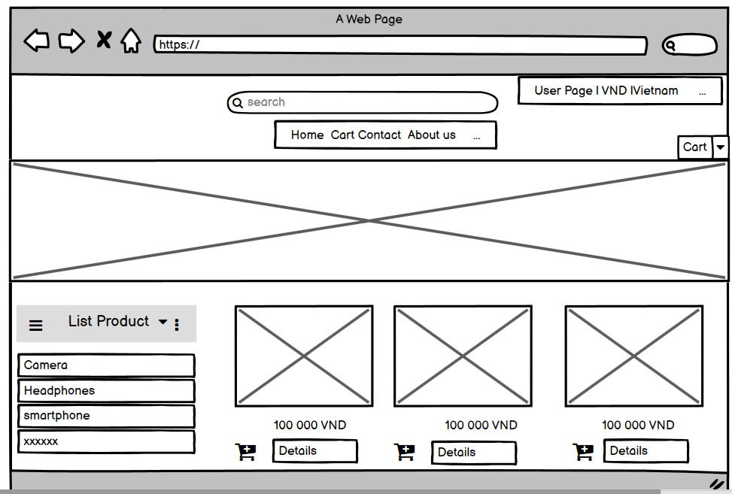

Figure 9:user home page of the system

-website login page of the system Q camera

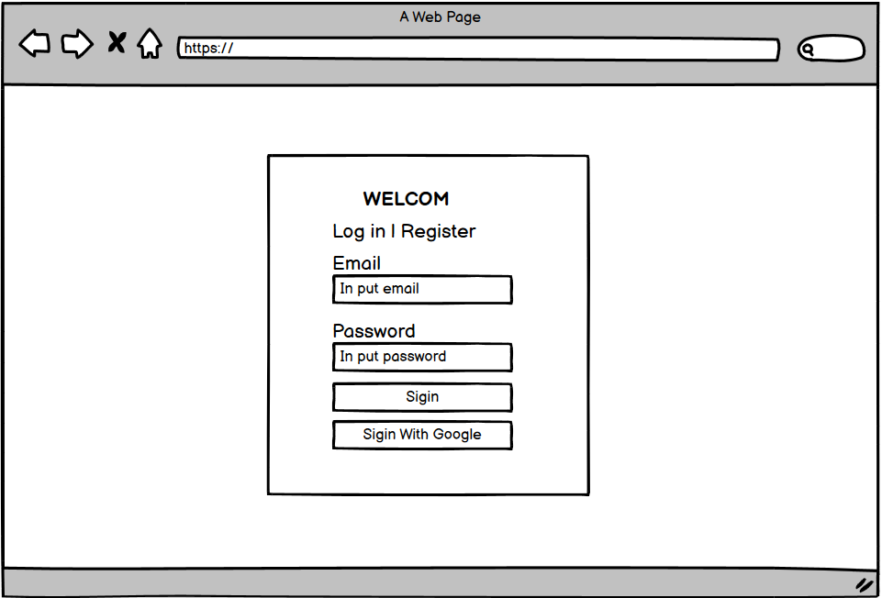

Figure 10: login page

-website register page of the system Q camera

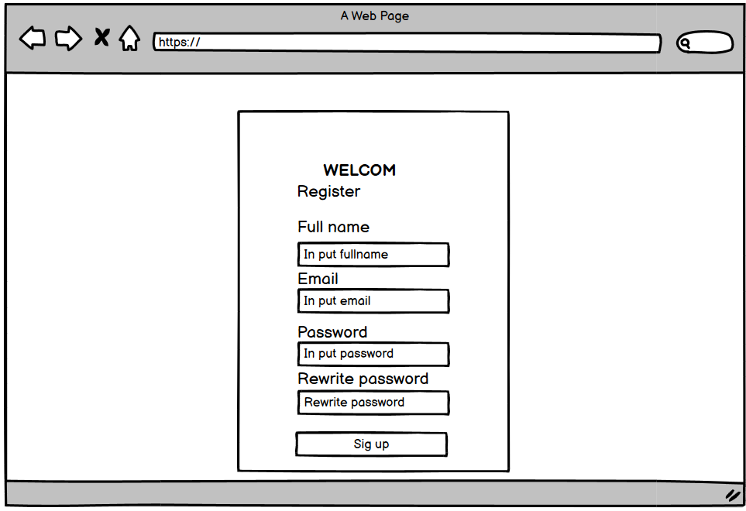

Figure 11: Register of

-website main page when user begins login of the system Q camera



Figure 12: shop page

**This is the homepage of the user made when buying a camera from the shop**

* Website admin interface

- **Dashboard Page**

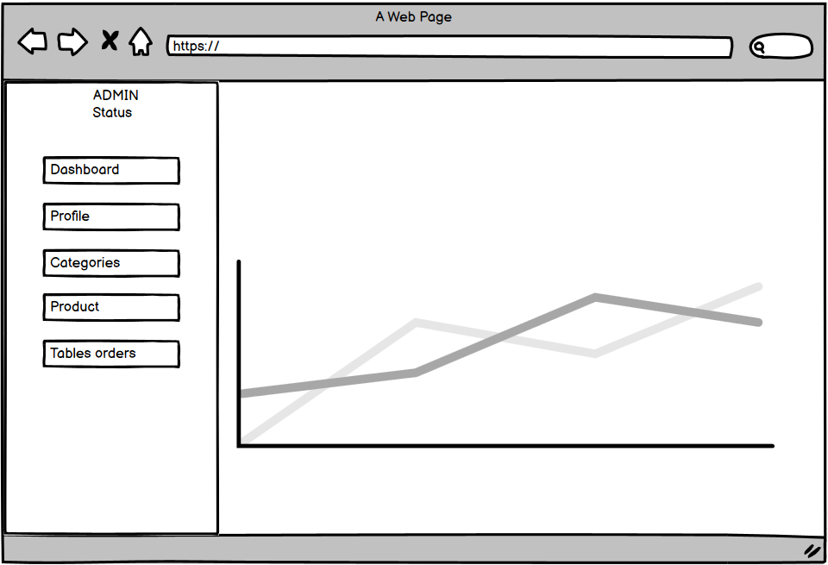

Figure 13: admin page manager

This is the admin's revenue chart page

-website add product page

and this is the admin's overall product management page, you can add and delete any products you need

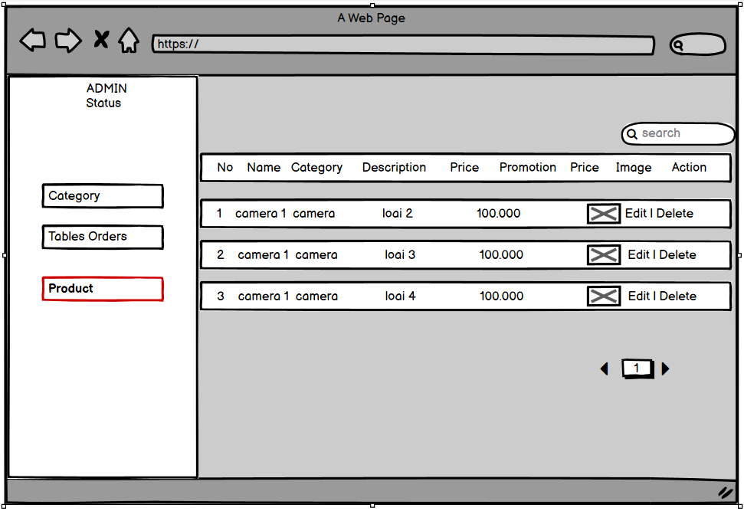

Figure 14: manager product (admin)

- website view product page

This is the admin's detailed overview of added products



Figure 15: shop page user

**-This is a shop page that includes products and other product categories.**

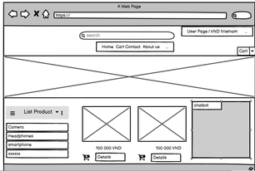

Figure 16: category page

**This is a shop page that includes products and other product categories.**

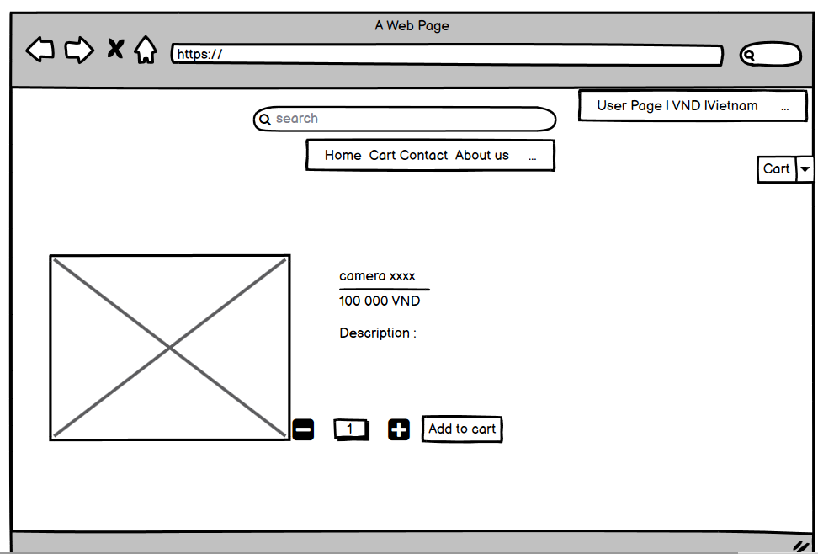

Figure 17: product detail page

**this is the admin's order management page, can see the overall order that the user has ordered**

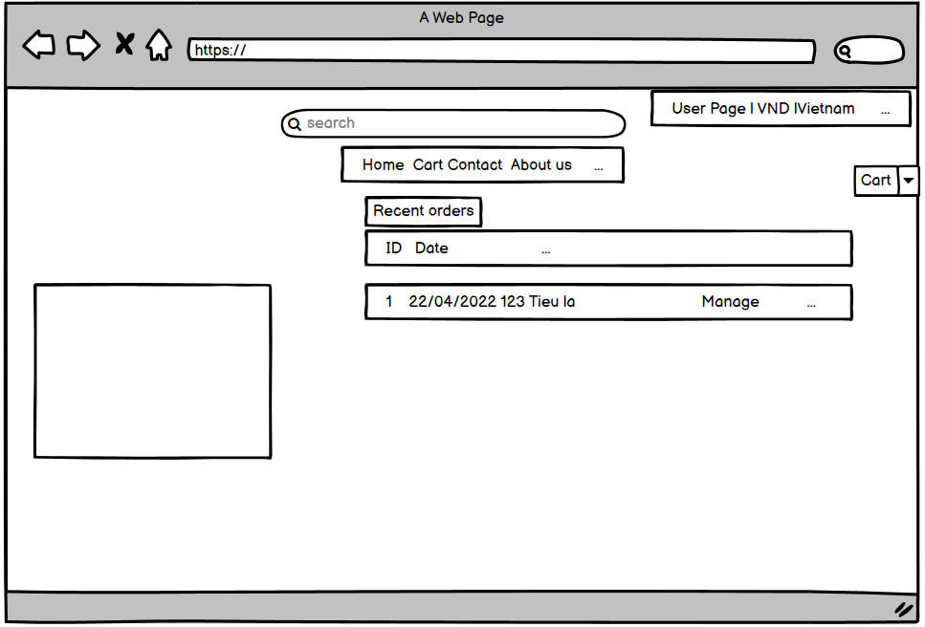

Figure 18: manager order detail

**This is the payment page with the form of payment is VNpay through the bank**

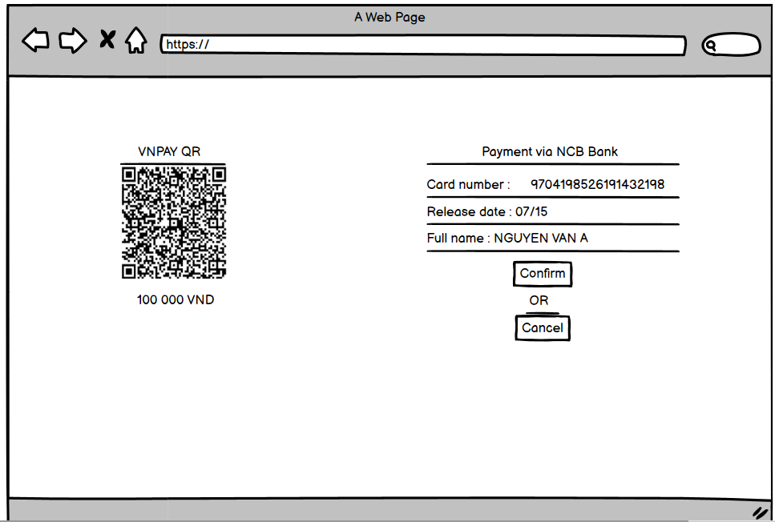

Figure 19: payment pay

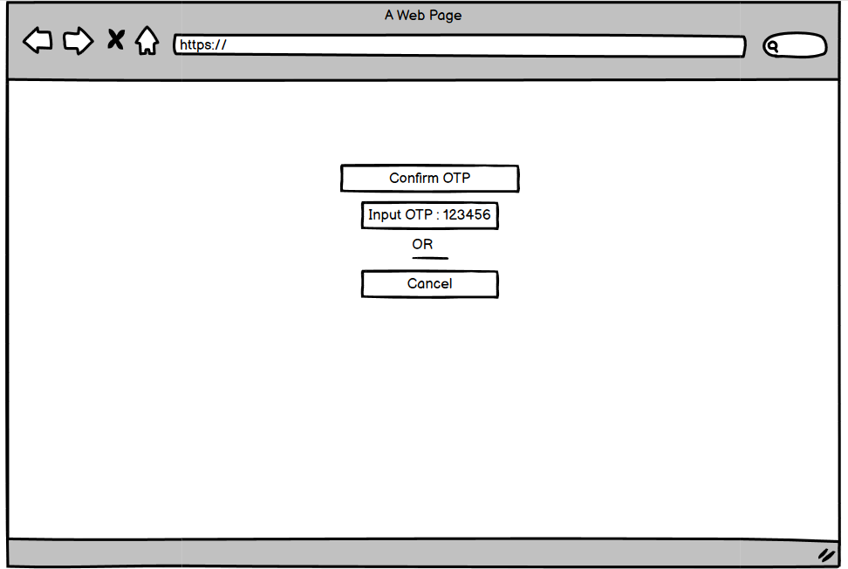

Figure 20: OTP pay

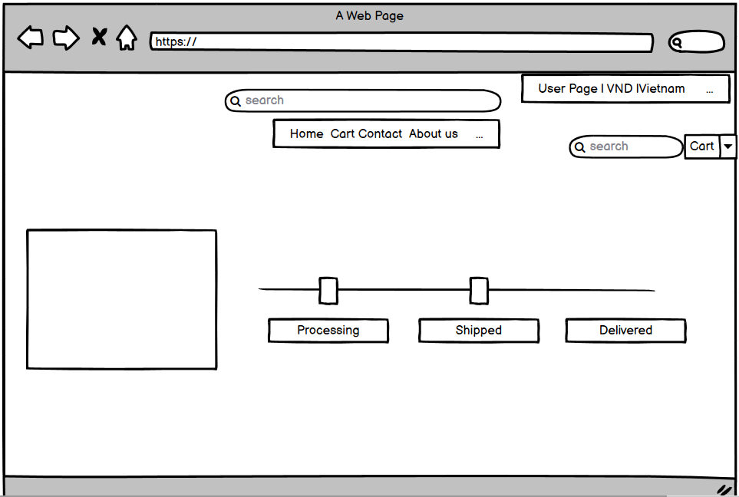

Figure 21: processing product

**5.7 Class diagram of the system**

The components that make up a system are displayed and interacted through this diagram, the most important drawing in the system is probably here. The following figure depicts the static structure of the system:

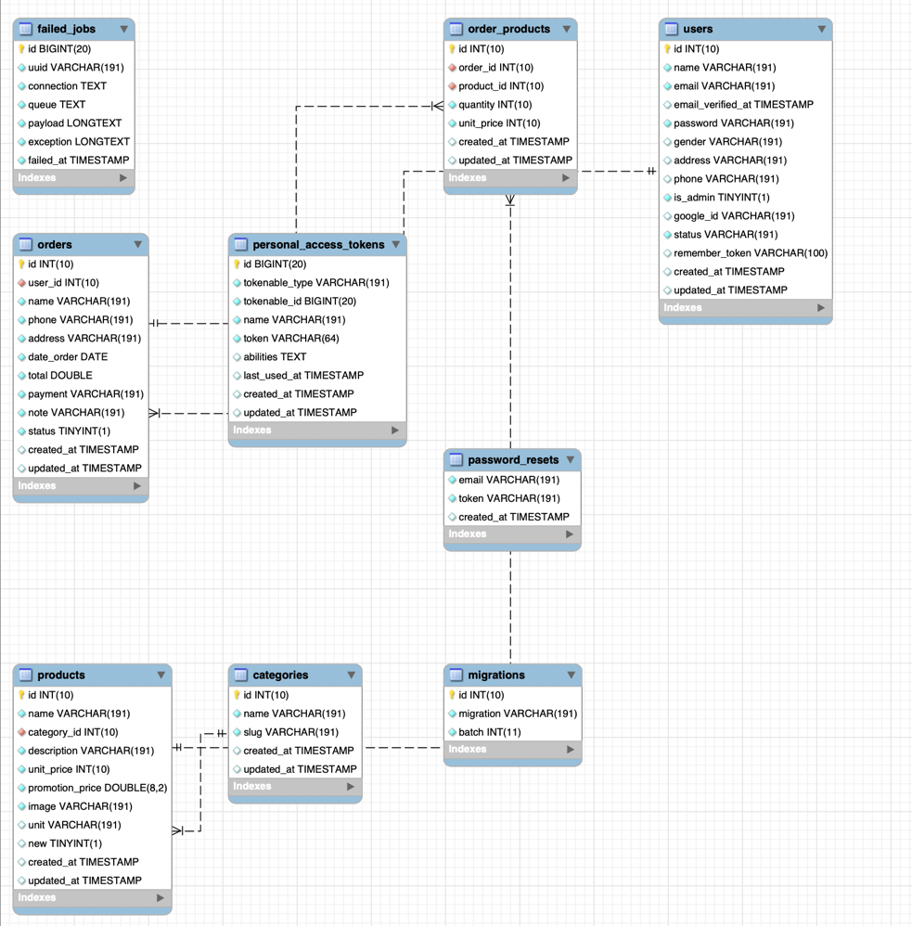

Figure 22: class diagram of the system

### **Activity diagram of the system**

Activity diagrams can be used to describe systems. Activity diagrams describe the flow of activity through a series of behaviors.

* **User-side activity diagram**

Below is the display diagram of users in the system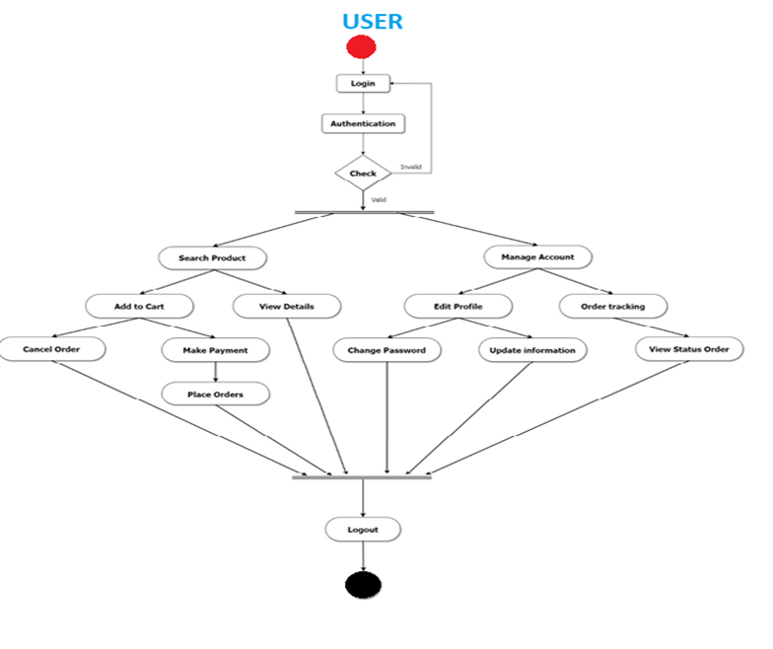

Picture 23: user activity diagram

* **Admin side activity diagram**

The diagram below depicts the administrator's actions in the system:

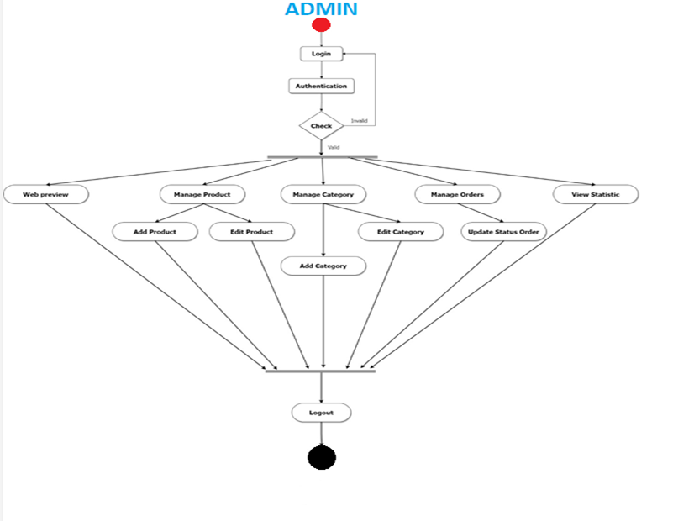

Picture 24: admin activity diagram

## 6 . THE PRODUCT'S DEVELOPMENT

### **6.1 System database**

In this project, I selected MySQL as the database in the technology selection section of the product design. An e-commerce project, I created feature models as follows:

**6.1.1 Product table in MySQL database**

When creating a commerce website, the first is to collect product data. To do this well, I created a table with the following fields: product name, description, image, price, inventory, and category. A product will be stored in the Products table and stored in the MySQL database using fields.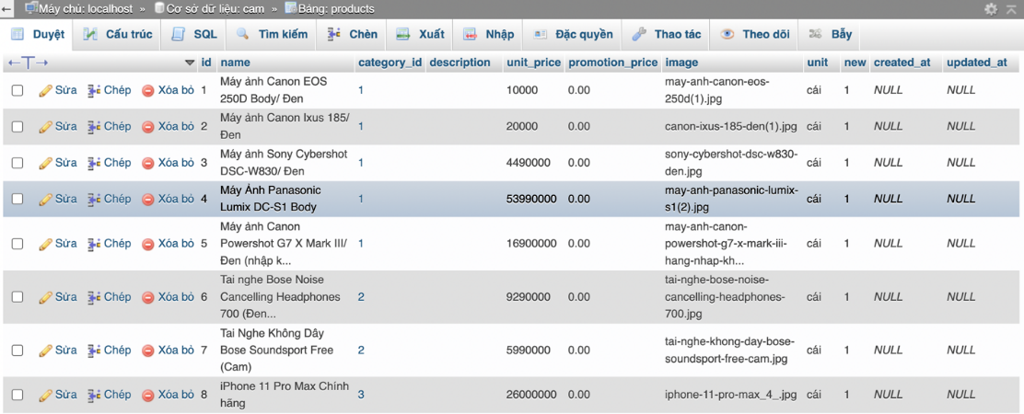

Figure 25:a database of the product

**6.1.2 Categories Table in MySQL database.**

I have created a category to categorize products to organize them into categories, making it easier to manage and show them to users.

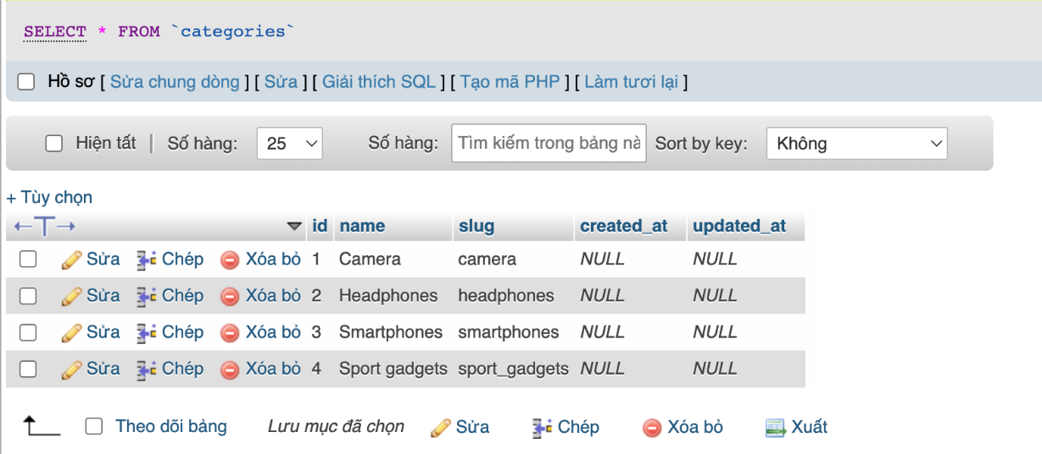

Figure 26: table category database

**6.1.3 User Table in MySQL database.**

After you've decided what things you intend to sell, consider how you'll represent the system's consumers. Information storage will aid in the development of long-term relationships with clients, such as the ability to present goods that are relevant to them. As a result, I created a database for users that contains information about customers that register to use the system. The customer must initially register to use all the features of the system. The user’s table in the MySQL database records information submitted by customers. Users and administrators share a table that includes basic information such as name, email, password, phone, and other information. other individuals, as well as authentication fields.

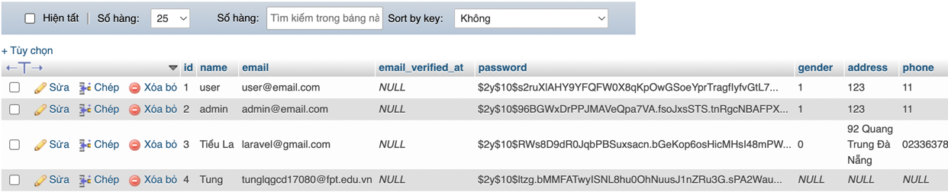

Figure 27: user table database

**6.1.4. Table of Orders in MySQL database**

When a user uses the ordering feature, the information is split into two tables after the order is placed successfully. "order product" is the first table, which provides information about the product and the quantity of the ordered product.

The second table is the order table, which will contain full information about the order, including address, phone number, ordered product, price, order status, and order date. These two tables will be linked so that the admin can quickly handle orders and keep track of the status of the users' orders.

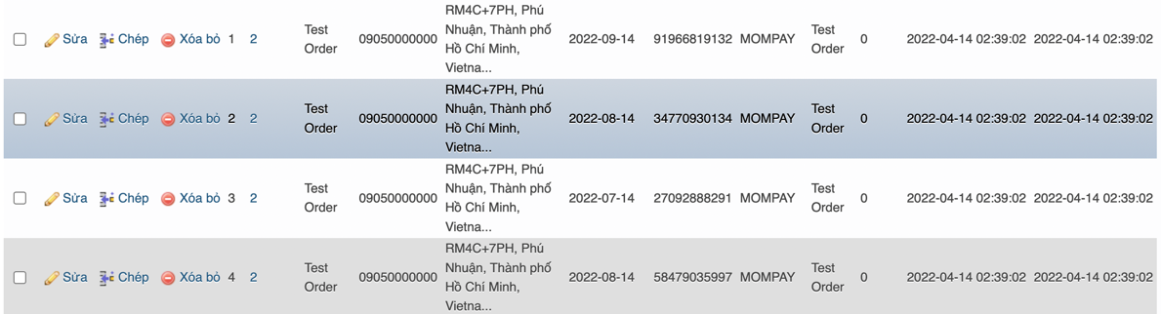

Figure 28: table order database

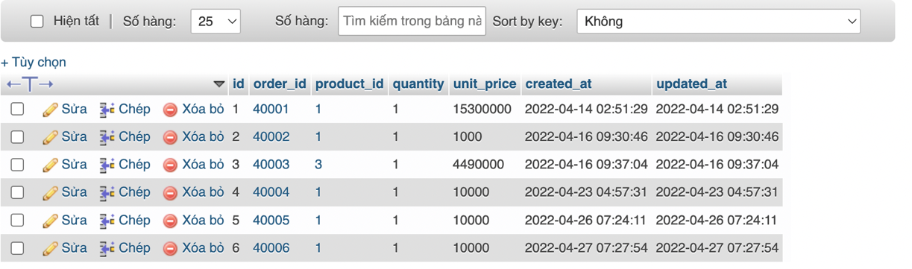

### **6.2 System front end**

**6.2.1. Web Development of the system**

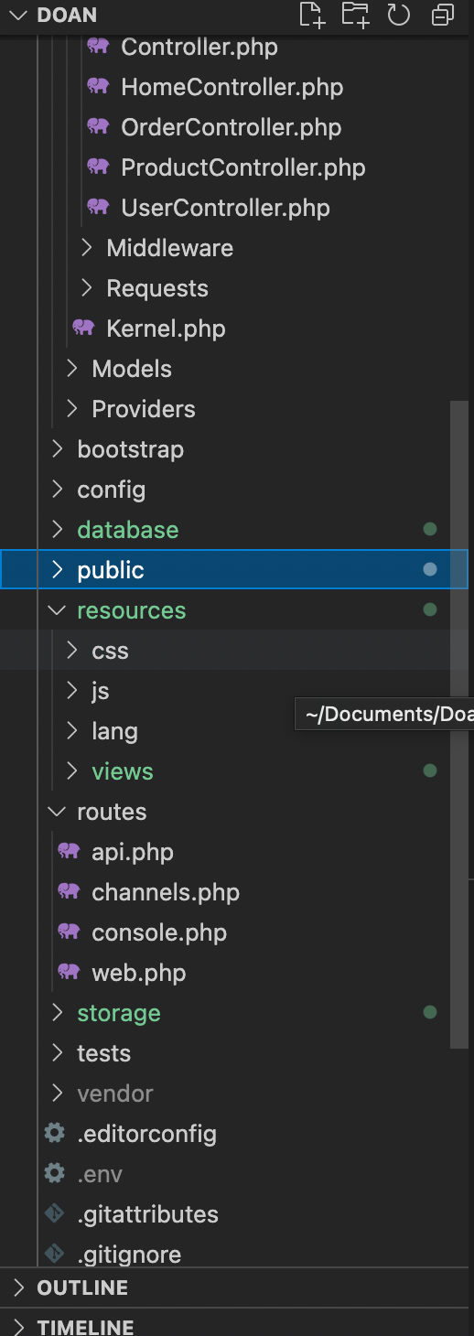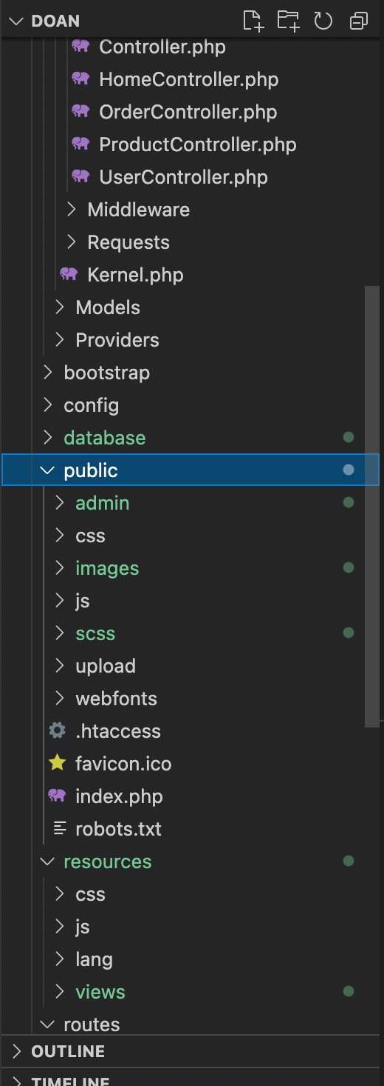

This time, the project's front-end structure is divided into two distinct components based on the two previously decentralized responsibilities of "admin" and "user."

The views folder in Resources/views includes view files that produce the user interface.

The 'public' folder contains the photos used on this website. The directory containing the index.php file is the public directory, it is the project portal for all requests, just like the HTML, JavaScript, and CSS files.

• a folder for pages

The first folder in this folder is the "Page Index" folder which includes the layout of the main site; The look and feel of these layouts are made easy on the eyes

Figure 29: mood board color

Above is the page UI code

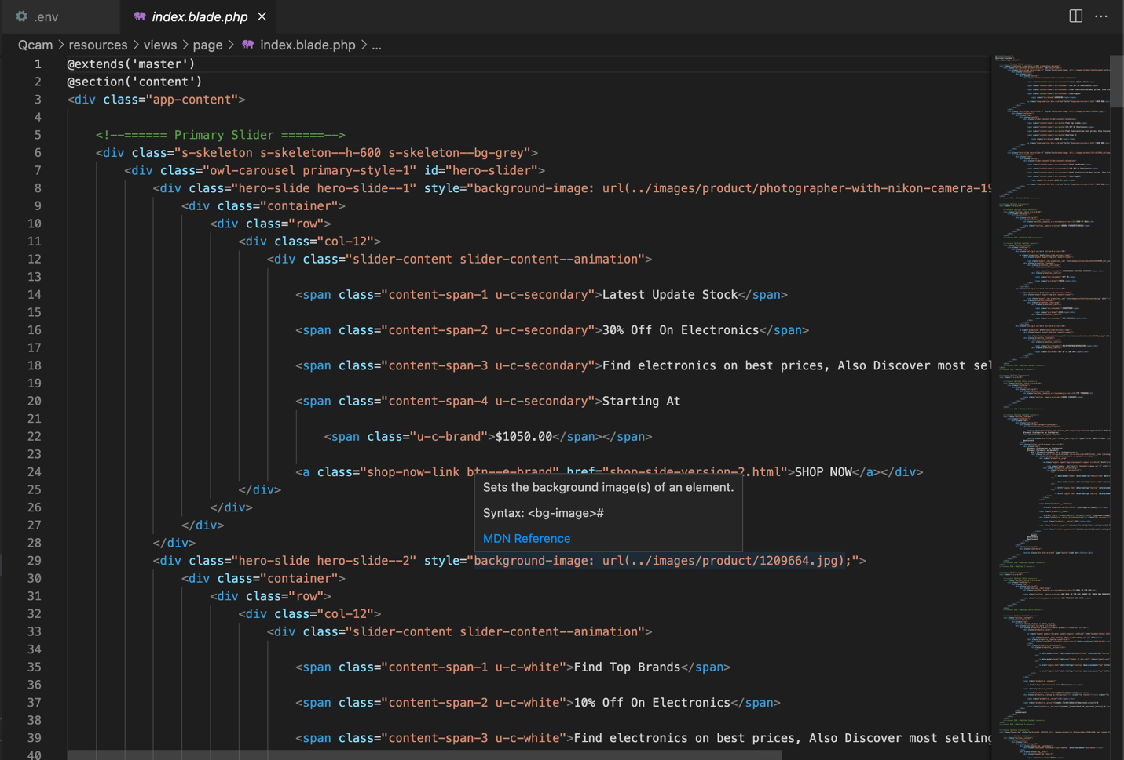

Figure 30: code index

and this is how it will appear once it has been developed and completed.



Figure 31: actual home page

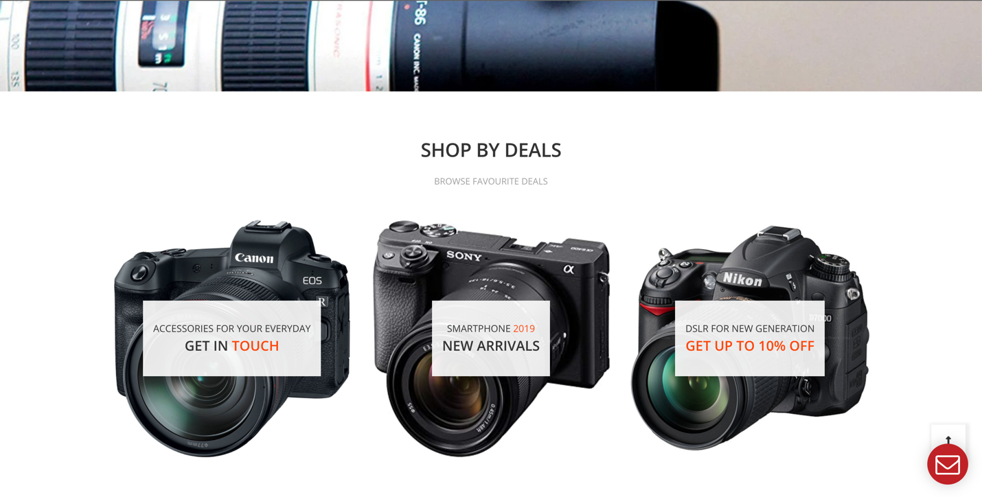

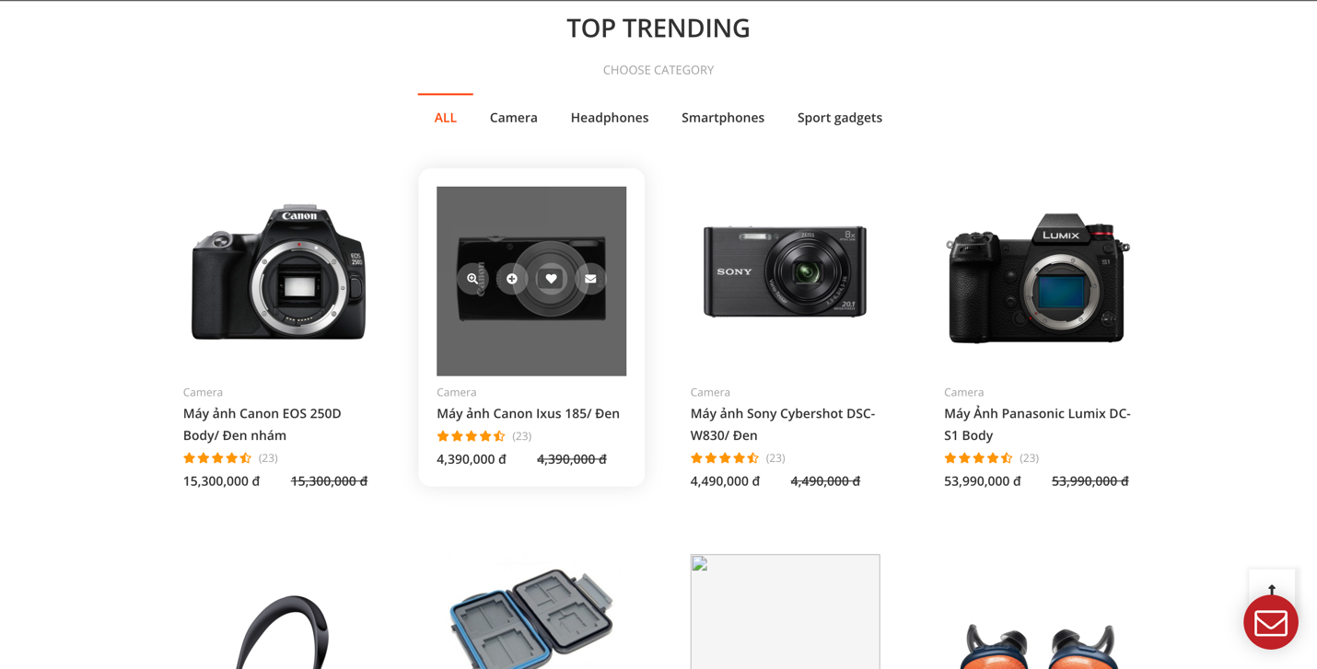

Figure 32: actual shop page

* **Administrator folder of the system**

**Separate permissions for administrators are kept in this area. Administrators have their own set of privileges and functions, including adding items, examining bills, and managing accounts. Folders are named after the function they perform, and they use that function to construct their layout.**

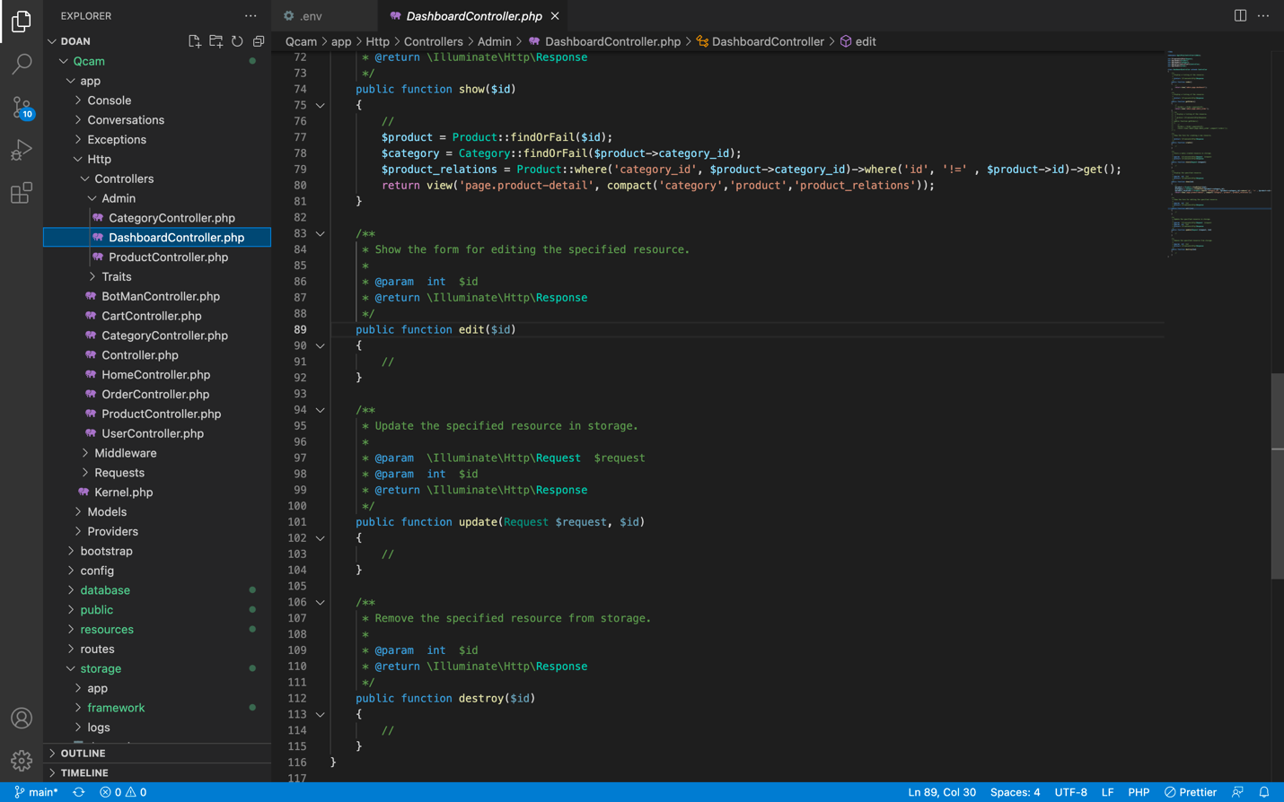

Figure 33: code dashboard

**This is where the system's administrator manages the accounts that have been created. He can update account information, cancel accounts, and create new ones.**

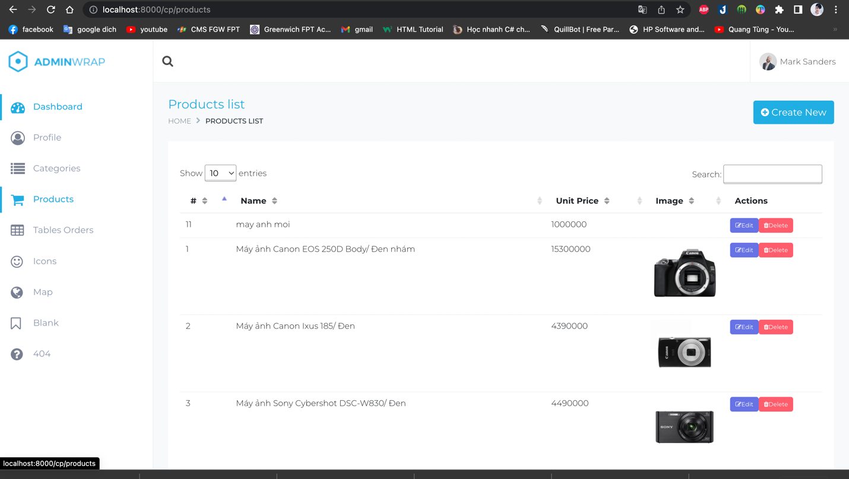

Figure 34: actual manager product

* **Account folder of the system**

**This is a subfolder of the account where we can manage accounts if we are logged in as an administrator and examine account information if we are logged in as a user.**

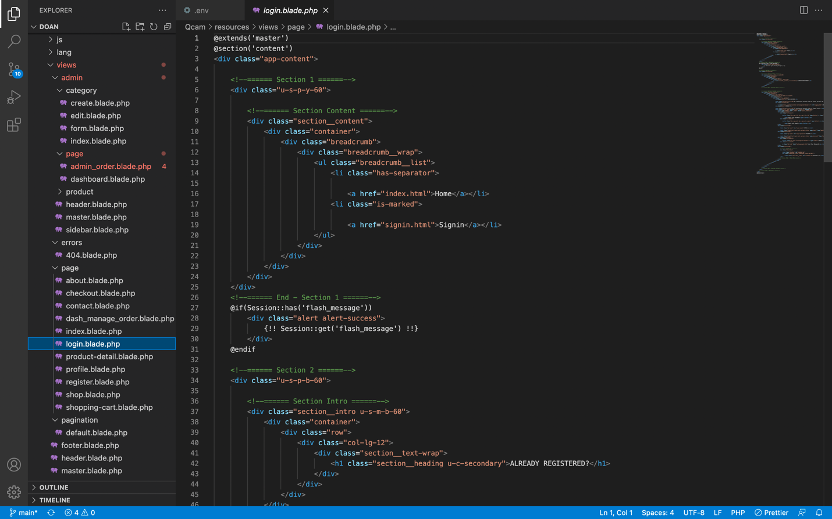

Figure 35: code login.blade

You can log in with an administrator account or a user account at this login page, or you can log in to both of these accounts right here.

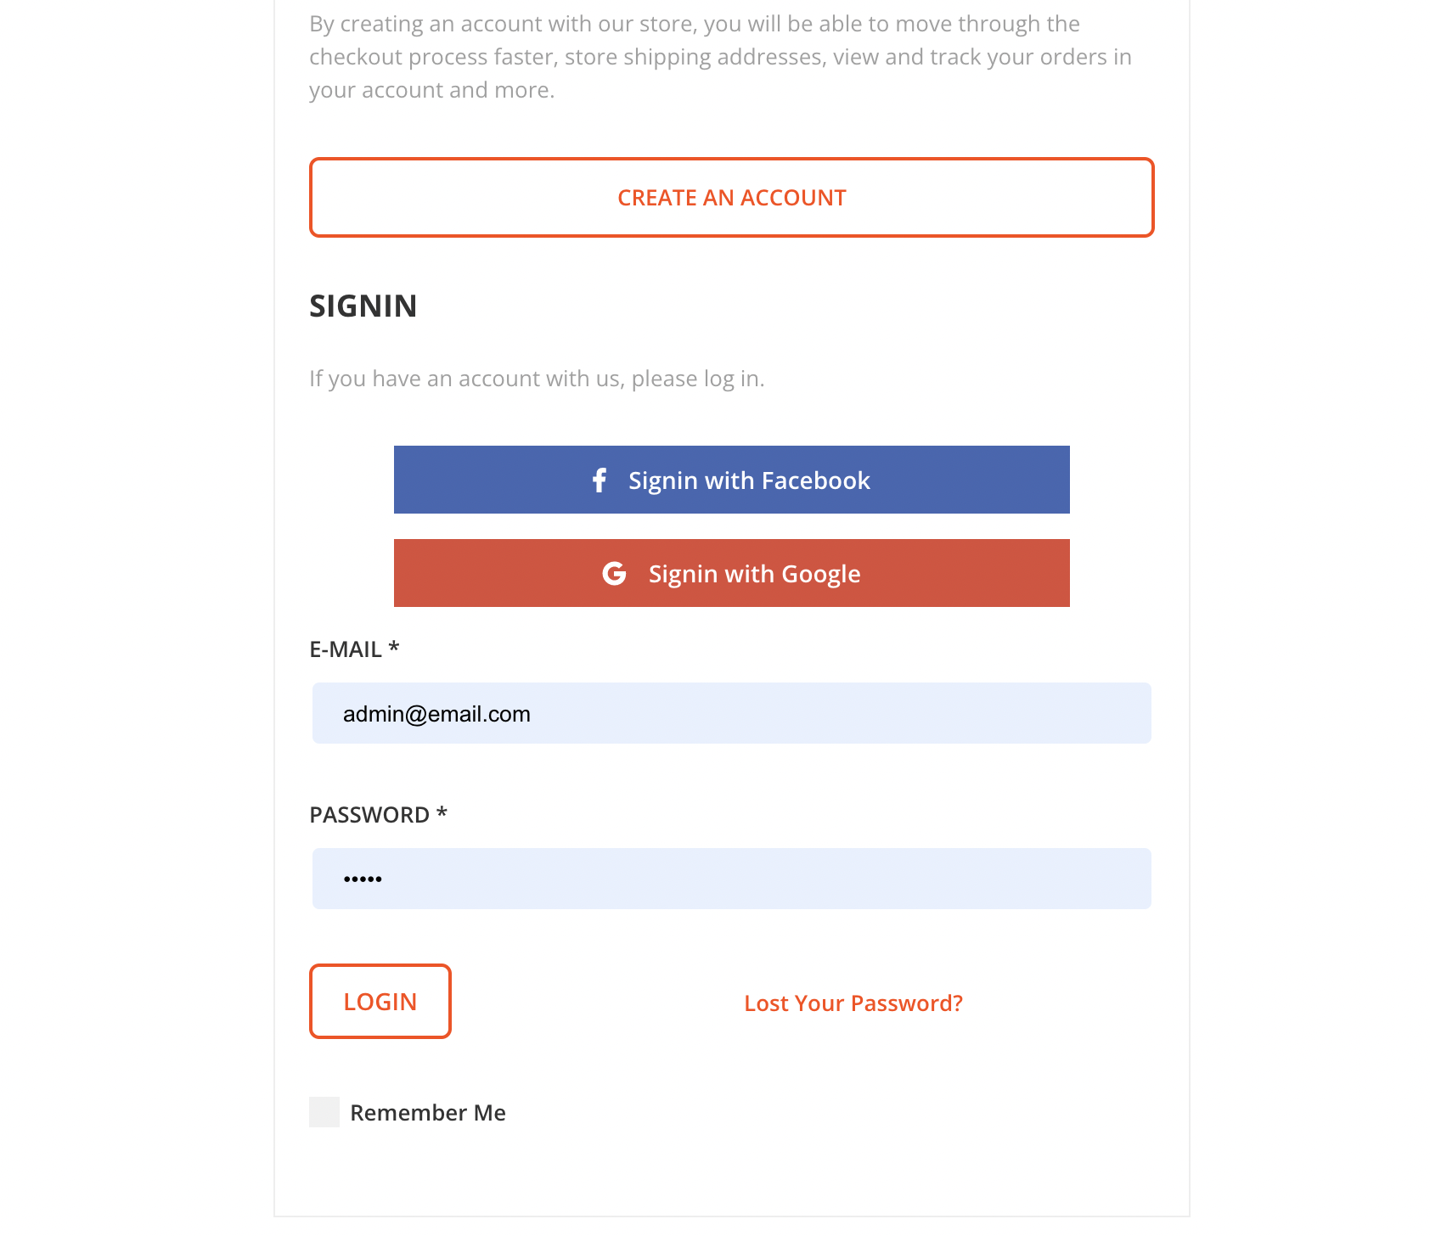

Figure 36: actual login page  
:

### **6.3.**Back end of the system

A website's back end consists of the server, application, and database. Maintain the system's seamless operation by handling all logic.

6.3.**1 Web Development of the system**

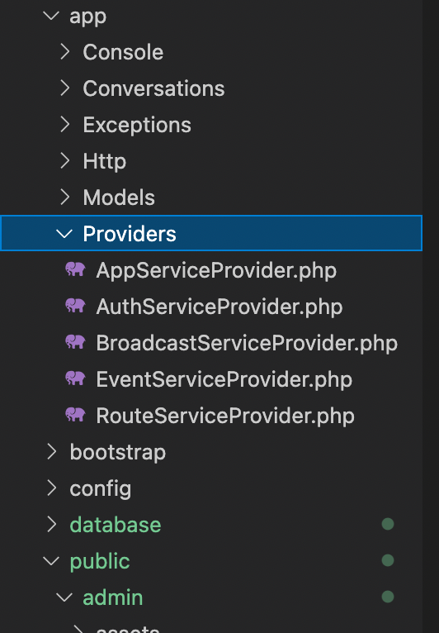

Figure 37: provider forder

The backend directory of the web platform is depicted in the diagram below. Folders are named and divided according to their functions, which are listed below and will be explained in detail:

* **Models Subfolder of the system**

The Model in MVC model is responsible for interfacing with the database. Eloquent, an ORM with an Active Record Pattern, is included with Laravel. (For more information, see ORM patterns). Each item in the Active Record Pattern represents a table row. Interacting with the database is now easier than ever.

* Controllers Subfolder of the system

We can write logic (math) in many different places, but it is best to write it all together in the Controller, especially for long and complex calculations.

The controller is designed where central processing logic should be used instead of writing calculations elsewhere.

Controllers are found in the Desktop/apps/Http/Controller/ directory.

See the following simple example to see how a Controller operates at its most basic level.

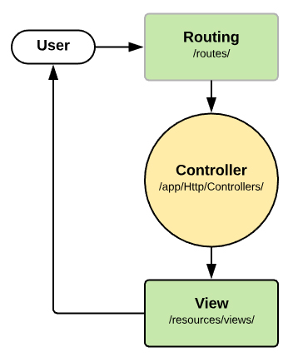

Figure 38: mvc model

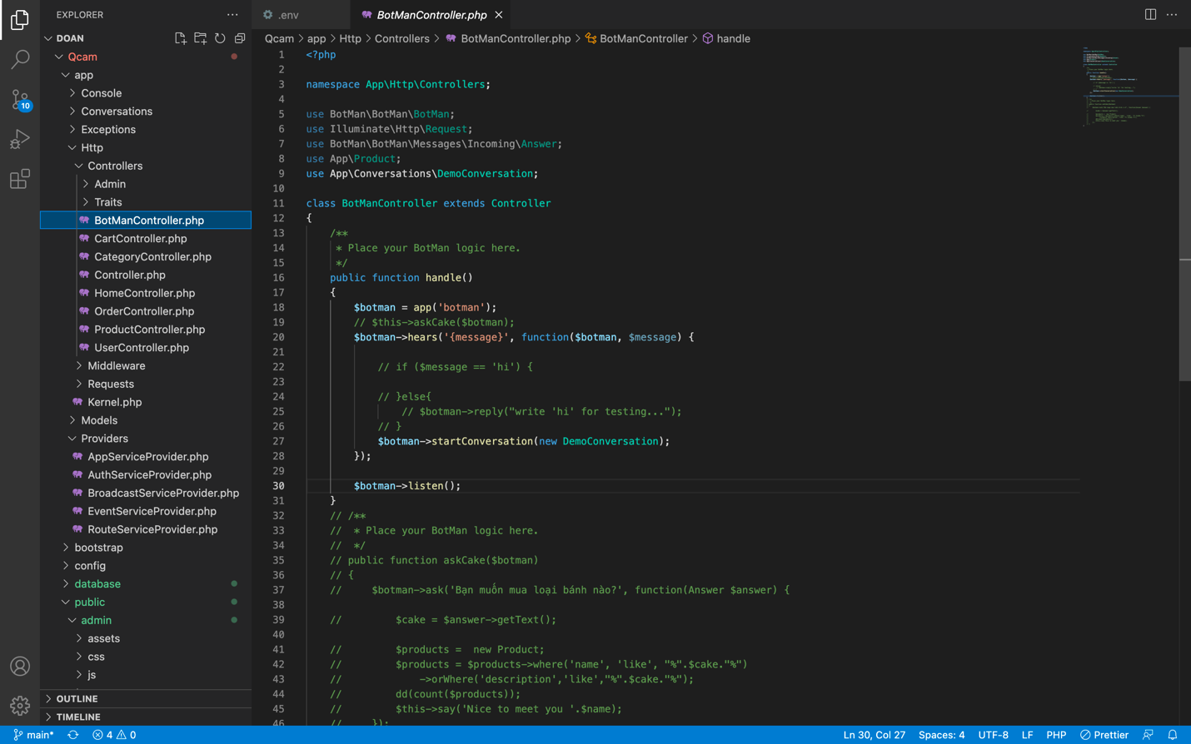

Figure 39: code controler

• Routes Subfolder of the system

The route directory contains all of the project's route controllers. Web.php,channels.php,api.php and console.php are the files that you can access.

Laravel is a framework that helps us choose routes and is also quite easy to use. It is divided into the following sections:

The GET method is used to receive the request via Route::get.

POST requests are received via route::post.

The PUT method is used to receive the request by Route::put.

The DELETE method is used to receive the request from Route::delete.

POST, GET, PUT, and other sophisticated methods are combined in Route::match.

Any method is returned by route::any.

Route::group is a function that builds route groups.

The equivalent controller that we define ourselves is called Route::controller.

With resource controller, route::resource is used.

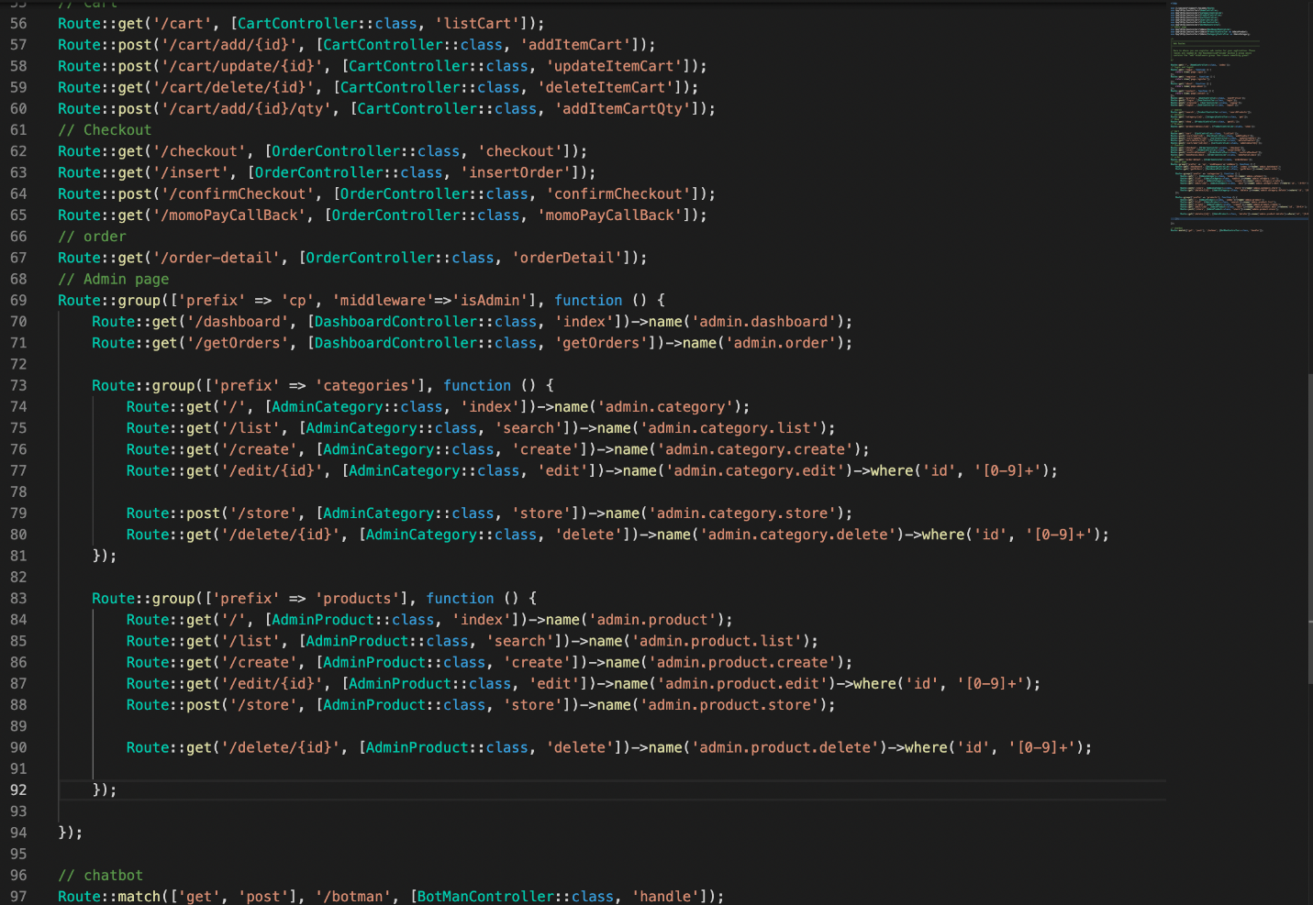

Figure 40: code router

• The system's Validator Subfolder

The validate method takes an HTTP request and applies a validation rule to it. Your code will run normally if the validation rule is successful; however, if authentication fails, a message will be given and an error will be sent to the user. A response will be given if there is an HTTP request and a JSON response will be sent when the AJAX query is made.

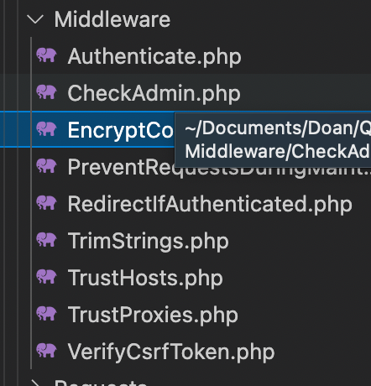

### 6.5 Screenshot of the system

**6.5.1 web development of the system**

* **Camera home page**

**When we aren't logged in, this is how the homepage appears.**

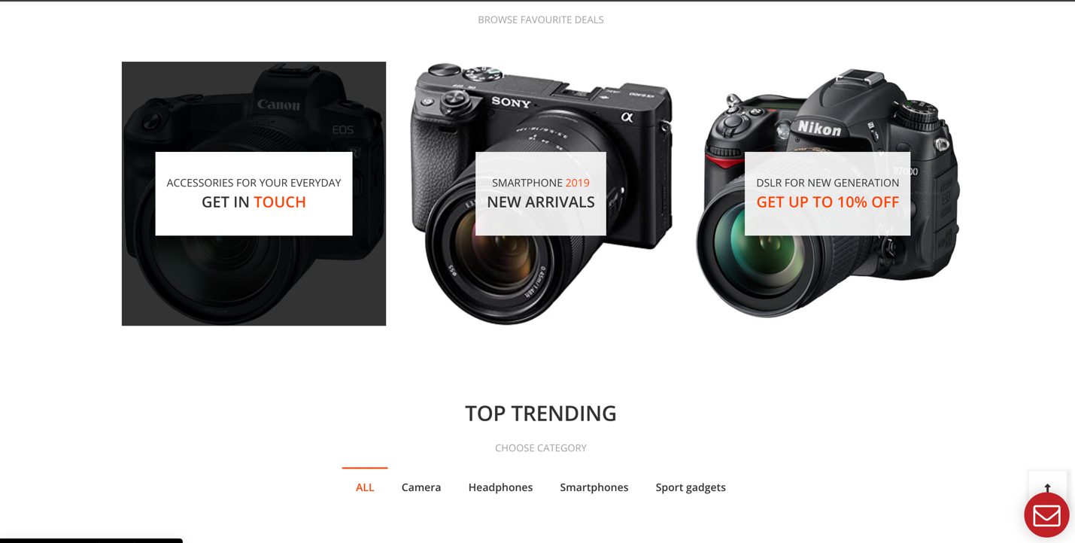

* Camera Login page

You can log in with an Admin account, or create an account here if you don't have an account yet.

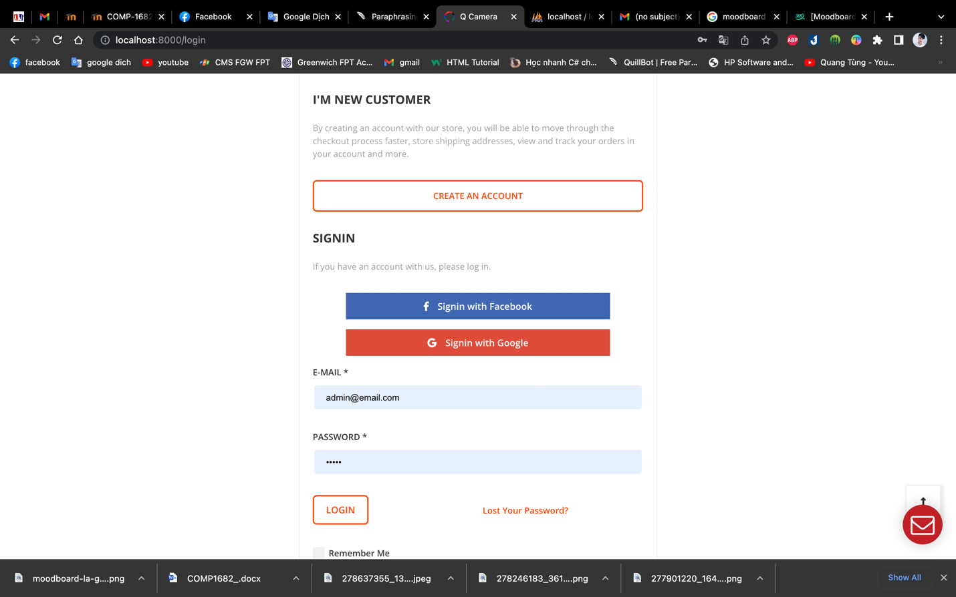

* Admin page of the Q camera

When an administrator logs in to the website, this is the interface that appears. The admin's management page is shown below; he can see his monthly revenue chart and make acceptable business adjustments.

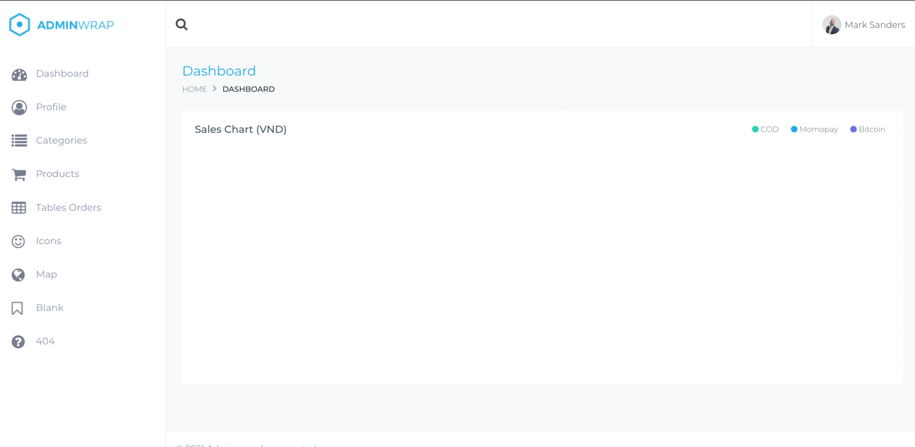

* **Manage the category of the Q CAMERA**

**The admin can use this page to view existing categories as well as edit, delete, and add new ones.**

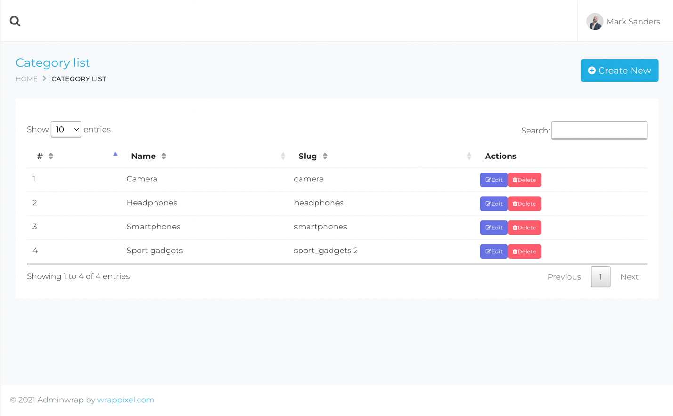

* **Manage the bill of the Q Camera store**

Admin can use this tool to manage orders in the system. He'll be in charge of analyzing orders or removing orders that are out of stock at the store.

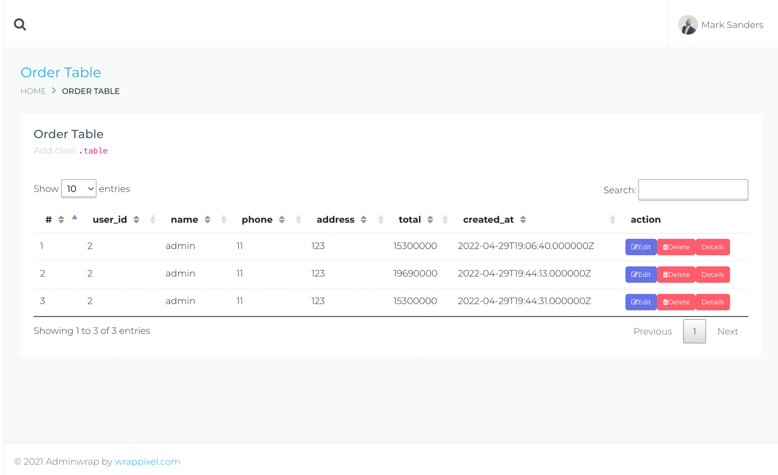

* **Manage product of the Q camera Store**

On this page, the administrator can control all of his items, including setting the price, stock quantity, and kind, as well as adding additional cameras.

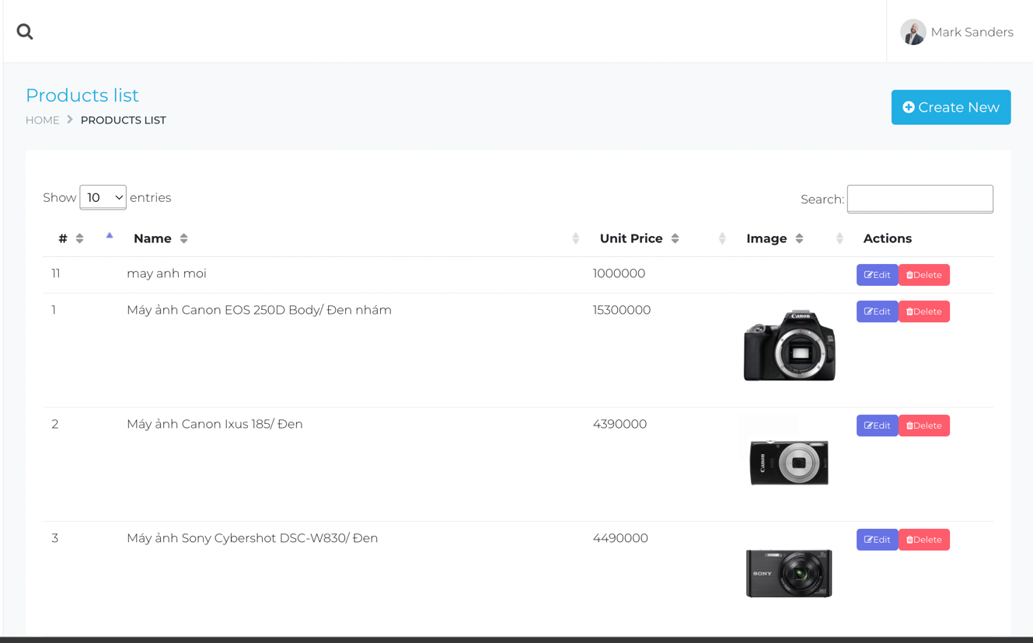

* **User page of the system Q camera**

**The next step is for the user to log into the system.**



* Chatbot support

when customers use the chatbot system to place a purchase or make a selection on the website.

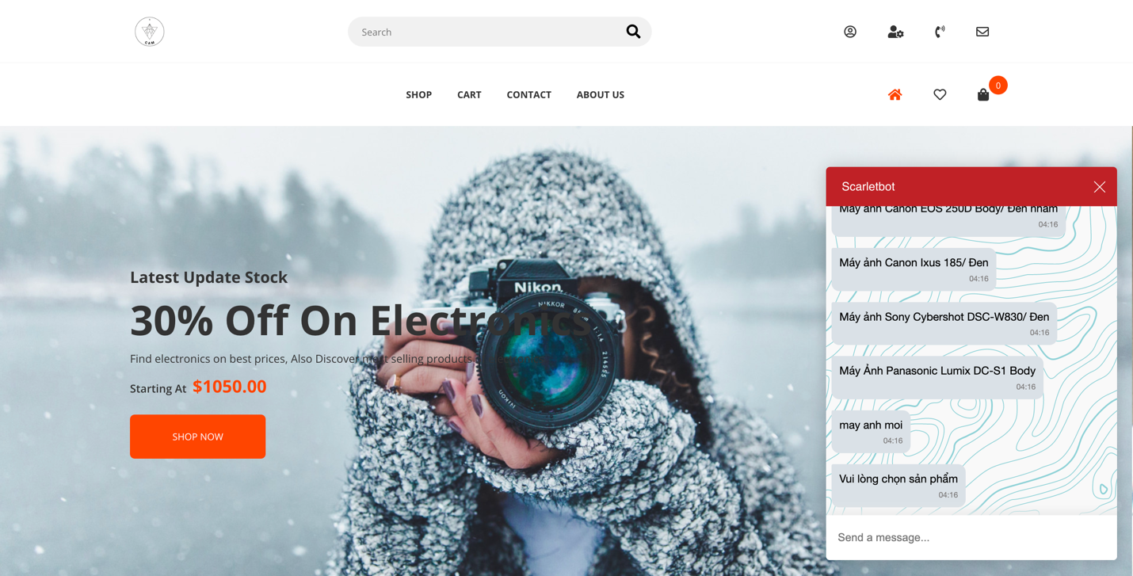

* Payment with Vnpay

make payments easily and conveniently without having to take any of the traditional steps before, no money left over, and many other advantages.

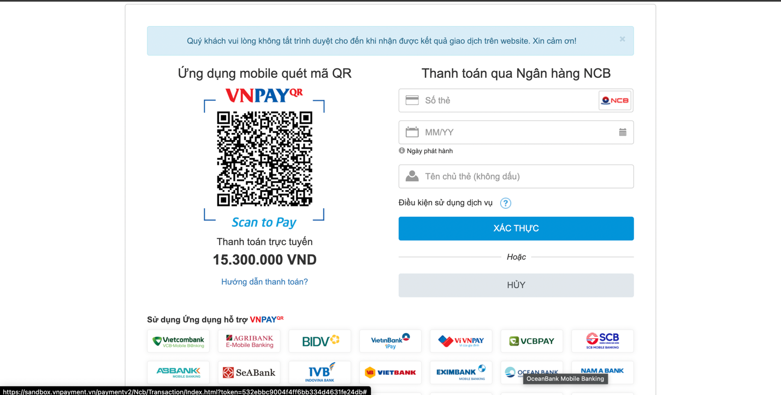

### 6.6 System testing

6.6.1 Test case

|  |  |  |  |  |
| --- | --- | --- | --- | --- |
| ID. | Things are being checked? | How do you feel | Use test data | Outcome |
| 1 | Create an account by entering your email | On the registration page, the visitor user fills in the essential information. | Name: Quang Tung  Email:  [Tunglqgcd17080@fpt.edu.vn](mailto:Tunglqgcd17080@fpt.edu.vn)  Password: QT1234 | The system checks the information and displays a message that you have successfully registered |
| 2 | Try logging in with an unregistered email account | This account is Invalid | Email: [test@gmail.com](mailto:test@gmail.com)  Password: Test@123 | The system will give an invalid account message correct, please try again. |
| 3 | Search function | In the homepage's search field, type in the name of the product you're looking for. | Do fill in the product name (eg camera) | The system will find products that match the keyword and then show the home page |
| 4 | Products can be filtered by category. | On the shop page, check the category box. | In the filter, check the "headphone" box. | The number of products is displayed by the system after it receives the operation. |
| 5 | Add the item to your shopping cart | To add a product to the cart, log in to your user account and pick the product. | Select the item then click the button"Add to Cart". | The operation is received by the system, and the quantity of products in the cart is displayed in the cart status. |
| 6 | Orders for payment | Check the items in your cart, then input your shipping address and phone number, choose your final payment option, and click the "Buy" button. | Adress: 40/2 Nguyễn Thiện kế  Number phone: 0333815273  Payment pay  payment through NCB  9704198526191432198  07/15 | The system will issue a successful payment notification |
| 7 | Order products with a chatbot | Login to your user account then click on the chatbot then try to enter the product name to search, enter the name, and address, and click go to the order. | Fill in the key may anh  Adress: 40/2 Nguyễn Thiện Kế  Phone 0333815273 | The system will confirm and take you to the order to pay |
| 8 | Add products | Go to the product management page then select add product item after logging in to the admin account. | Fill out all of the product's information. | The system alerts you that you have successfully added products and takes you to the product list. |
| 9 | delete the product from the system. | Go to the product list page and choose the product after logging in to the admin account. | if you want to delete then press the delete button in the product column | The product is updated on the system after you have removed it from the list |
| 10 | Update product details | Update and fill in the information to amend using the Administrator account on the list of product select page. | Changes in product pricing | The redirect information to the listing page is confirmed by the system. |

**6.6.2 Test log**

|  |  |  |
| --- | --- | --- |
| ID. | Experience results | Pictures prove |
| 1 | The system will notify you if your registration was successful. |  |
| 2 | The system will alert you; please double-check the information. |  |
| 3 | The system looks for goods that match the information you've provided. |  |
| 4 | The system shows products from the chosen category. |  |
| 5 | Notice has been added to your shopping basket. |  |
| 6 | A notification stating that the order was successful appears. |  |
| 7 | The product has been added to the system successfully, according to the notification. |  |
| 8 | The product will be removed from the system, and it will be reloaded automatically. |  |
| 9 | When the update is complete, the system will alert you. |  |
| 10 | When the editing is complete, the system will notify you. |  |
| 11 |  |  |

After the customer clicks on the payment item, the system will switch to a new screen to enter payment information.

At the payment screen, customers have many different payment options. There are several payment methods that customers can choose from: Select the payment method by scanning the QR code displayed right on the screen, hoose a form of payment by paying with domestic banks linked to the web.

* if the customer chooses to pay by QR code and this QR code belongs to VNPAY bank, so when you put the QR code on the scanning screen, the system will automatically recognize VNPAY bank and allow you to pay.
* when customers choose to pay by domestic bank accounts. When the customer chooses one of the banks shown below, the system will ask you to enter the necessary payment information in the fields to the right of the QR code. After entering all the required information of the bank, the customer will click on the verification box for the system to check and proceed to payment. If the payment is successful, the system will notify the customer that the payment has been successful and print an invoice for the customer. If the payment fails, the system will notify the user on the screen that the payment is faulty and please try again.

# **7. CONCLUSION**

In the past time, what I learned at school is reflected in this report. From basic to advanced courses a team of passionate teachers. with a lot of experience and instilled knowledge, I get into software engineering faster.

Since I took this course I have faced a lot of difficulties in the development process, from thematic thinking about functions to development is my problem. approaching new technology, and techniques, and also suffering from the Covid-19 pandemic that is relapsing phase 2 and extending to phase 4 of the pandemic, but I can't just let time pass in vain like that, but must strive to study new techniques to fulfill the requirements of this subject well. That's my challenge for the time being.

Through this course, not only did I learn a lot of knowledge, but it also helped me realize where I am, how I am, and how much effort I need. My advantages and disadvantages so that I can learn from them next time. Maybe the result will not be high but it will be the strength, and the effort to overcome difficulties during this period.

And this project is made for the purpose, I want to apply my knowledge and experience to build my e-sales system in the future, an e-commerce website to sell cameras, and accessories and improve business operations. The economy is at a time when the whole world is in trouble. But this project is just the beginning of development, my system has a lot of development directions because e-commerce is a very developed industry, so after the course In this study, I will spend my time developing upgrades for the system to be more diverse and unique in terms of features, more convenient for users.

For me, this last project of the year was a fighting moment about overcoming the bigger challenges of this life, and this course is also the foundation, the root to help me. overcome all the difficulties to come.